**THỰC HÀNH BUỔI 1**

Nguyễn Dương Quốc Huy

1150070017

**LAB 1**

**1. Tạo dự án đơn giản với Android Studio**

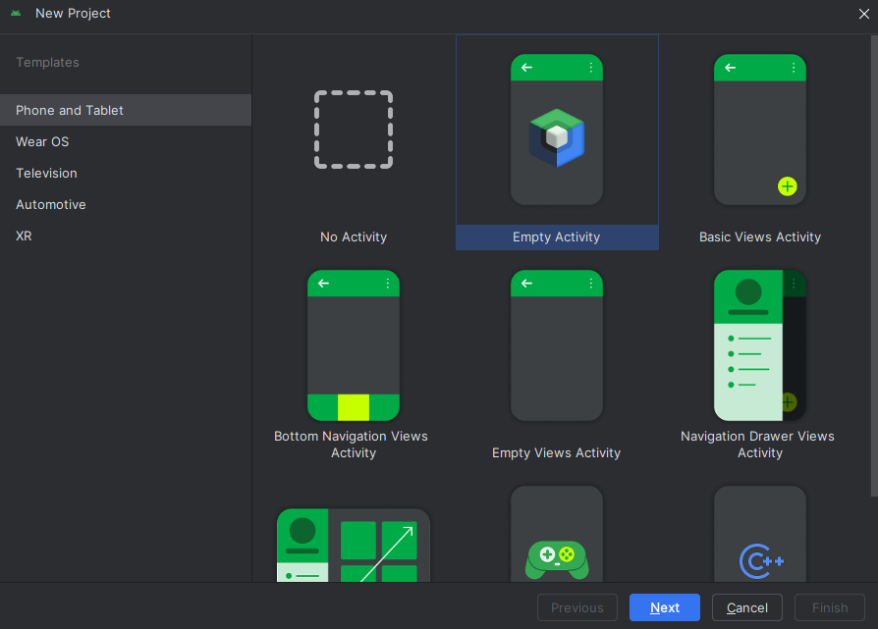**Bước 1:** Mở Android Studio, vào File, chọn New Project, chọn Empty Activity

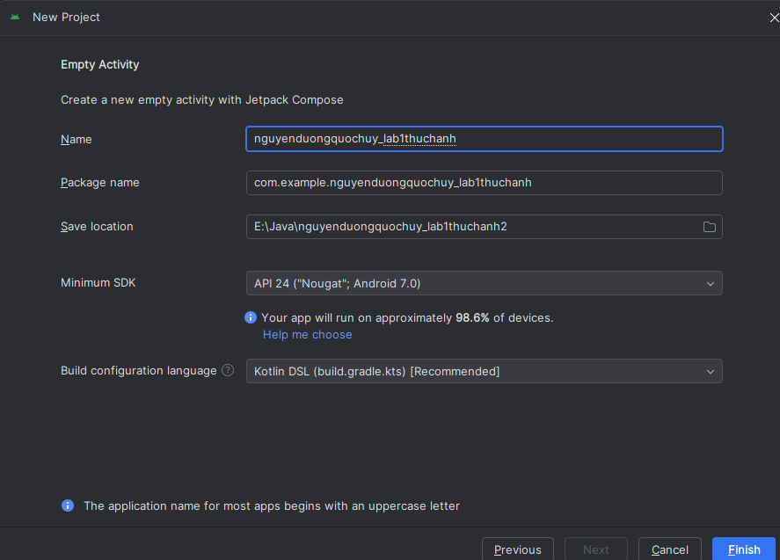Đặt tên cho dự án như hình, nhấn Next cho tới khi chương trình chạy xong:

**Bước 2:** Trong activity_main.xml, sửa lại giao diện như sau.

**1.app/src/main/res/layout/activity_main.xml.**

<?xml version="1.0" encoding="utf-8"?>  
<LinearLayout xmlns:android="http://schemas.android.com/apk/res/android"  
 android:layout_width="match_parent"  
 android:layout_height="match_parent"  
 android:orientation="vertical"  
 android:weightSum="10"  
 android:padding="16dp">  
  
 <!-- EditText 1 -->  
 <EditText  
 android:id="@+id/edtX"  
 android:layout_width="match_parent"  
 android:layout_height="0dp"  
 android:layout_weight="1"  
 android:hint="@string/hint_x"  
 android:gravity="center"  
 android:inputType="numberDecimal" />  
  
 <!-- EditText 2 -->  
 <EditText  
 android:id="@+id/edtY"  
 android:layout_width="match_parent"  
 android:layout_height="0dp"  
 android:layout_weight="1"  
 android:hint="@string/hint_y"  
 android:gravity="center"  
 android:inputType="numberDecimal" />  
  
 <!-- TextView Kết quả -->  
 <TextView  
 android:id="@+id/tvResult"  
 android:layout_width="match_parent"  
 android:layout_height="0dp"  
 android:layout_weight="1"  
 android:text="@string/ket_qua"  
 android:gravity="center"  
 android:textSize="16sp" />  
  
 <!-- Hàng nút (một nút + như hình) -->  
 <LinearLayout  
 android:layout_width="match_parent"  
 android:layout_height="0dp"  
 android:layout_weight="1"  
 android:orientation="horizontal"  
 android:weightSum="5">  
  
 <Button  
 android:id="@+id/btnPlus"  
 android:layout_width="0dp"  
 android:layout_height="match_parent"  
 android:layout_weight="1"  
 android:text="+" />  
 <!-- Chừa trống 4 phần còn lại -->  
 </LinearLayout>  
  
 <!-- Phần trống cho giống bố cục demo -->  
 <LinearLayout  
 android:layout_width="match_parent"  
 android:layout_height="0dp"  
 android:layout_weight="6" />  
</LinearLayout>

**2.app/src/main/java/com/example/nguyenduongquochuy_lab1thuchanh/MainActivity.java.**

package com.example.nguyenduongquochuy_lab1thuchanh;  
  
import android.os.Bundle;  
import android.widget.Button;  
import android.widget.EditText;  
import android.widget.TextView;  
import androidx.appcompat.app.AppCompatActivity;  
  
public class MainActivity extends AppCompatActivity {  
  
 private EditText edtX, edtY;  
 private TextView tvResult;  
 private Button btnPlus;  
  
 @Override  
 protected void onCreate(Bundle savedInstanceState) {  
 super.onCreate(savedInstanceState);  
 setContentView(R.layout.*activity_main*);  
  
 edtX = findViewById(R.id.*edtX*);  
 edtY = findViewById(R.id.*edtY*);  
 tvResult = findViewById(R.id.*tvResult*);  
 btnPlus = findViewById(R.id.*btnPlus*);  
  
 // Xử lý nút "+"  
 btnPlus.setOnClickListener(v -> {  
 String sx = edtX.getText().toString().trim();  
 String sy = edtY.getText().toString().trim();  
 if (sx.isEmpty() || sy.isEmpty()) {  
 tvResult.setText("Vui lòng nhập đủ X và Y");  
 return;  
 }  
 try {  
 double x = Double.*parseDouble*(sx);  
 double y = Double.*parseDouble*(sy);  
 tvResult.setText("Kết quả: " + (x + y));  
 } catch (NumberFormatException e) {  
 tvResult.setText("Giá trị không hợp lệ");  
 }  
 });  
 }  
}

**3.app/src/main/res/values/strings.xml.**

<resources>  
 <string name="app_name">Lab1ThucHanh</string>  
 <string name="hint_x">Nhập X</string>  
 <string name="hint_y">Nhập Y</string>  
 <string name="ket_qua">Kết quả</string>  
</resources>

**4.app/src/main/AndroidManifest.xml.**

<manifest xmlns:android="http://schemas.android.com/apk/res/android"  
 package="com.example.nguyenduongquochuy_lab1thuchanh">  
  
 <application  
 android:allowBackup="true"  
 android:label="@string/app_name"  
 android:supportsRtl="true"  
 android:theme="@style/Theme.Material3.DayNight.NoActionBar">  
 <activity  
 android:name=".MainActivity"  
 android:exported="true">  
 <intent-filter>  
 <action android:name="android.intent.action.MAIN" />  
 <category android:name="android.intent.category.LAUNCHER" />  
 </intent-filter>  
 </activity>  
 </application>  
</manifest>

**Kết quả:**

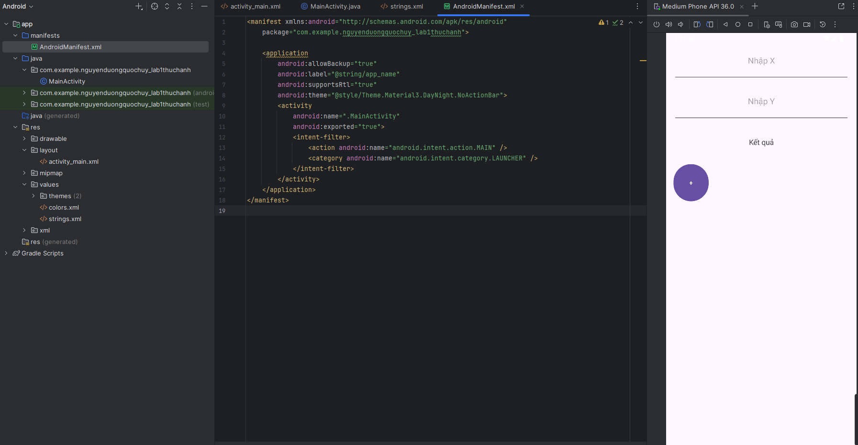

**Bước 3:**

Trong lớp MainActivity của Java, bổ sung các thành phần sau phía trên đầu class:

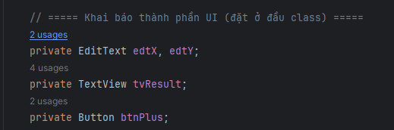

Viết phương thức làm cầu nối để chuyển đổi đối tượng từ Java sang XML:

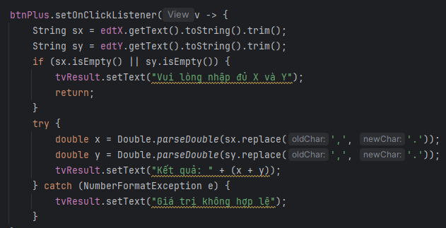

Gọi phương thức innitControl() trong hàm onCreate(...) sau lệnh setContentView:

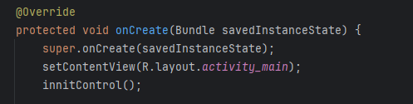

**Bước 4:** Tạo sự kiện nhấn nút: Trong hàm initControl(), gõ đoạn code như sau để tạo sự kiện cho Button:

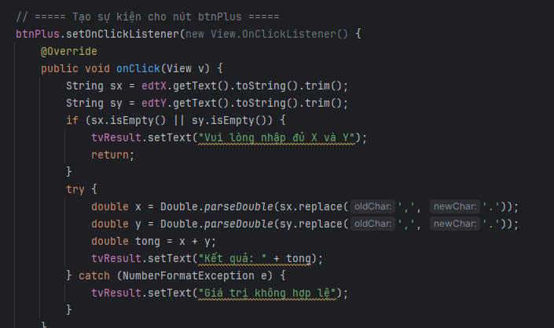

**Bước 5:** Chạy ứng dụng bằng cách ấn vào nút sau: .Lưu ý bạn phải cài sẵn máy ảo

**Bước 6:** Để nâng cao khả năng linh hoạt trong lập trình di động, các chuỗi và màu sắc cần phải được khai báo trong tài nguyên. Vào thư mục values\strings.xml, khai báo các đối tượng như sau:

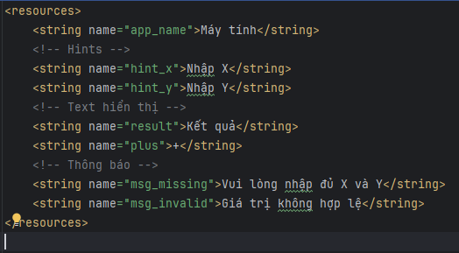

Thêm 2 dòng text: android:text="@string/result" /> và android:text="@string/plus" />

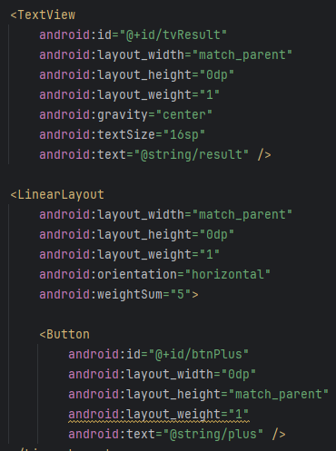

**2. Tiếp tục dự án sử dụng Camera**

**1.Layout: app/src/main/res/layout/activity_main.xml.**

<?xml version="1.0" encoding="utf-8"?>  
<LinearLayout xmlns:android="http://schemas.android.com/apk/res/android"  
 android:layout_width="match_parent"  
 android:layout_height="match_parent"  
 android:orientation="vertical"  
 android:weightSum="6"  
 android:padding="16dp">  
  
 <Button  
 android:id="@+id/btnCamera"  
 android:layout_width="match_parent"  
 android:layout_height="0dp"  
 android:layout_weight="1"  
 android:text="@string/chup_anh" />  
  
 <ImageView  
 android:id="@+id/imgPhoto"  
 android:layout_width="match_parent"  
 android:layout_height="0dp"  
 android:layout_weight="5"  
 android:scaleType="centerCrop"  
 android:src="@drawable/photo" />  
</LinearLayout>

**2.app/src/main/java/com/example/nguyenduongquochuy_lab1thuchanh/MainActivity.java**

package com.example.nguyenduongquochuy_lab1thuchanh;  
  
import android.Manifest;  
import android.content.pm.PackageManager;  
import android.graphics.Bitmap;  
import android.os.Bundle;  
import android.view.View;  
import android.widget.Button;  
import android.widget.ImageView;  
import android.widget.Toast;  
  
import androidx.activity.result.ActivityResultLauncher;  
import androidx.activity.result.contract.ActivityResultContracts;  
import androidx.annotation.NonNull;  
import androidx.appcompat.app.AppCompatActivity;  
import androidx.core.content.ContextCompat;  
  
public class MainActivity extends AppCompatActivity {  
  
  
 private Button btnCamera;  
 private ImageView imgPhoto;  
  
  
 private final ActivityResultLauncher<String> requestCameraPermission =  
 registerForActivityResult(new ActivityResultContracts.RequestPermission(), isGranted -> {  
 if (isGranted) {  
 openCameraPreview();  
 } else {  
 Toast.*makeText*(this, "Bạn cần cấp quyền CAMERA để chụp ảnh", Toast.*LENGTH_SHORT*).show();  
 }  
 });  
  
 private final ActivityResultLauncher<Void> takePicturePreview =  
 registerForActivityResult(new ActivityResultContracts.TakePicturePreview(), (Bitmap bitmap) -> {  
 if (bitmap != null) {  
 imgPhoto.setImageBitmap(bitmap);  
 } else {  
 Toast.*makeText*(this, "Không nhận được ảnh từ Camera", Toast.*LENGTH_SHORT*).show();  
 }  
 });  
  
 @Override  
 protected void onCreate(Bundle savedInstanceState) {  
 super.onCreate(savedInstanceState);  
 setContentView(R.layout.*activity_main*);  
 initControl();  
 }  
  
 private void initControl() {  
 btnCamera = findViewById(R.id.*btnCamera*);  
 imgPhoto = findViewById(R.id.*imgPhoto*);  
  
 btnCamera.setOnClickListener(new View.OnClickListener() {  
 @Override public void onClick(View v) {  
 // Kiểm tra quyền CAMERA rồi mới mở camera  
 if (ContextCompat.*checkSelfPermission*(  
 MainActivity.this, Manifest.permission.*CAMERA* ) == PackageManager.*PERMISSION_GRANTED*) {  
 openCameraPreview();  
 } else {  
 requestCameraPermission.launch(Manifest.permission.*CAMERA*);  
 }  
 }  
 });  
 }  
  
 private void openCameraPreview() {  
 takePicturePreview.launch(null);  
 }  
}

**3.** **Strings: app/src/main/res/values/strings.xml**

<resources>  
 <string name="app_name">CameraDemo</string>  
 <string name="chup_anh">Chụp ảnh</string>  
</resources>

**4. Manifest: app/src/main/AndroidManifest.xml**

<manifest xmlns:android="http://schemas.android.com/apk/res/android"  
 package="com.example.nguyenduongquochuy_lab1thuchanh">  
  
 <uses-permission android:name="android.permission.CAMERA" />  
  
 <application  
 android:allowBackup="true"  
 android:label="@string/app_name"  
 android:supportsRtl="true"  
 android:theme="@style/Theme.Material3.DayNight.NoActionBar">  
  
 <activity  
 android:name=".MainActivity"  
 android:exported="true">  
 <intent-filter>  
 <action android:name="android.intent.action.MAIN" />  
 <category android:name="android.intent.category.LAUNCHER" />  
 </intent-filter>  
 </activity>  
 </application>  
</manifest>

**Kết quả:**

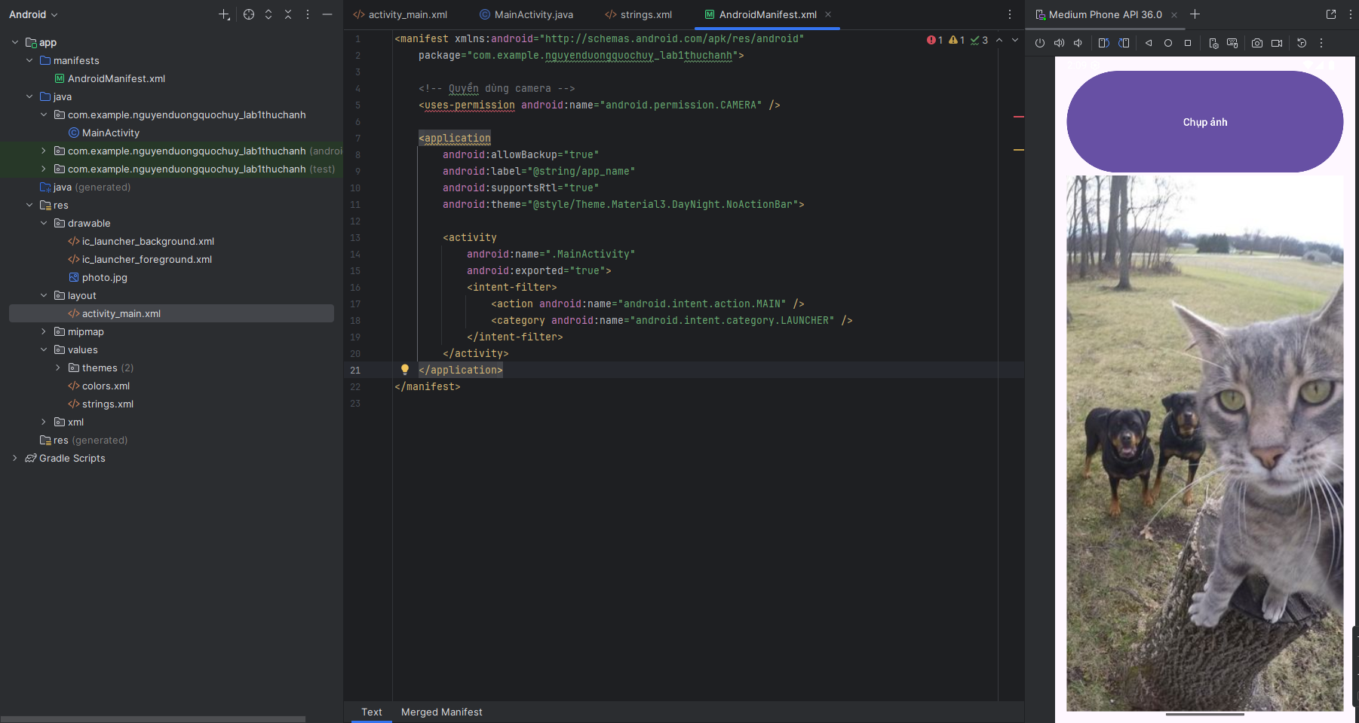

**Bước 2:**

Trong lớp MainActivity, khai báo đối tượng Button và ImageView như sau:

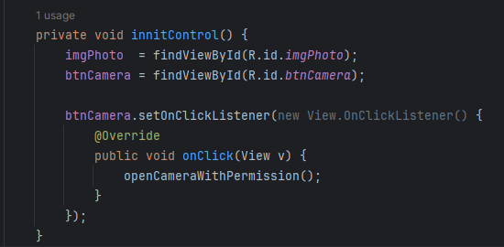

Tiếp theo, viết lệnh để khởi động Camera lên:

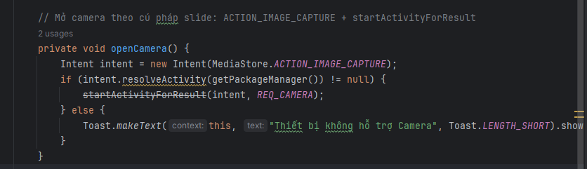

Tiếp theo, viết phương thức ngoài phương thức InnitControl() để nhận kết quả trả về khi chụp ảnh xong:

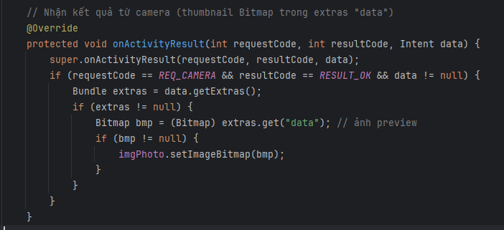

**Bước 3:** Để cho phép điện thoại sử dụng được chức năng của Camera, ta phải cấu hình như sau trong tập tin AndroidManifest.xml:

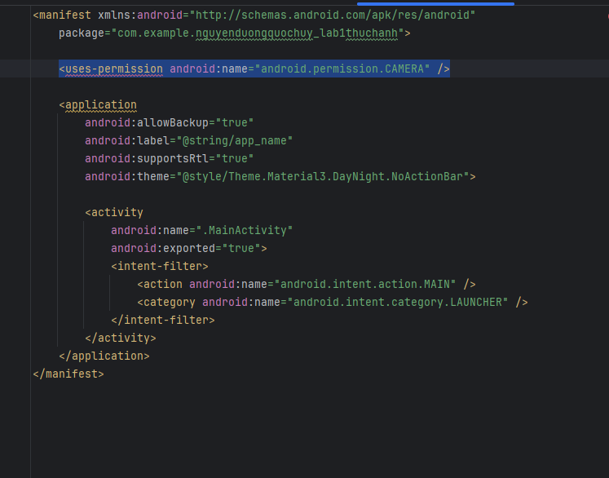

**Kết quả:**

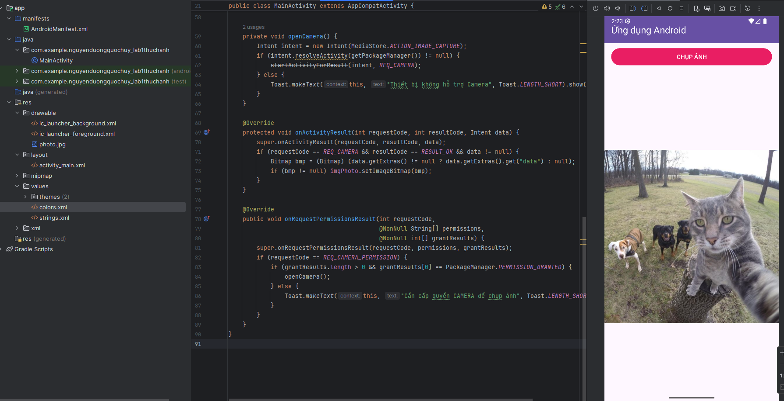

**3. Bài Tập**

**Bài tập 1:** Hoàn thiện các chức năng của một máy tính, có các phép +, -, *, /, %

**1.app/src/main/res/layout/activity_main.xml.**

<?xml version="1.0" encoding="utf-8"?>  
<LinearLayout xmlns:android="http://schemas.android.com/apk/res/android"  
 xmlns:app="http://schemas.android.com/apk/res-auto"  
 android:layout_width="match_parent"  
 android:layout_height="match_parent"  
 android:orientation="vertical"  
 android:weightSum="10"  
 android:padding="16dp">  
  
 <EditText  
 android:id="@+id/edtX"  
 android:layout_width="match_parent"  
 android:layout_height="0dp"  
 android:layout_weight="2"  
 android:hint="@string/hint_x"  
 android:inputType="numberDecimal"  
 android:gravity="center" />  
  
 <EditText  
 android:id="@+id/edtY"  
 android:layout_width="match_parent"  
 android:layout_height="0dp"  
 android:layout_weight="2"  
 android:hint="@string/hint_y"  
 android:inputType="numberDecimal"  
 android:gravity="center" />  
  
 <TextView  
 android:id="@+id/tvResult"  
 android:layout_width="match_parent"  
 android:layout_height="0dp"  
 android:layout_weight="1"  
 android:text="@string/result"  
 android:textSize="16sp"  
 android:gravity="center" />  
  
 <LinearLayout  
 android:layout_width="match_parent"  
 android:layout_height="0dp"  
 android:layout_weight="2"  
 android:orientation="horizontal"  
 android:weightSum="5">  
  
 <com.google.android.material.button.MaterialButton  
 android:id="@+id/btnAdd"  
 android:layout_width="0dp"  
 android:layout_height="match_parent"  
 android:layout_weight="1"  
 android:text="@string/plus"  
 android:textColor="@android:color/white"  
 app:backgroundTint="?attr/colorPrimary" />  
  
 <com.google.android.material.button.MaterialButton  
 android:id="@+id/btnSub"  
 android:layout_width="0dp"  
 android:layout_height="match_parent"  
 android:layout_weight="1"  
 android:text="@string/minus"  
 android:textColor="@android:color/white"  
 app:backgroundTint="?attr/colorPrimary" />  
  
 <com.google.android.material.button.MaterialButton  
 android:id="@+id/btnMul"  
 android:layout_width="0dp"  
 android:layout_height="match_parent"  
 android:layout_weight="1"  
 android:text="@string/mul"  
 android:textColor="@android:color/white"  
 app:backgroundTint="?attr/colorPrimary" />  
  
 <com.google.android.material.button.MaterialButton  
 android:id="@+id/btnDiv"  
 android:layout_width="0dp"  
 android:layout_height="match_parent"  
 android:layout_weight="1"  
 android:text="@string/div"  
 android:textColor="@android:color/white"  
 app:backgroundTint="?attr/colorPrimary" />  
  
 <com.google.android.material.button.MaterialButton  
 android:id="@+id/btnMod"  
 android:layout_width="0dp"  
 android:layout_height="match_parent"  
 android:layout_weight="1"  
 android:text="@string/mod"  
 android:textColor="@android:color/white"  
 app:backgroundTint="?attr/colorPrimary" />  
 </LinearLayout>  
  
 <LinearLayout  
 android:layout_width="match_parent"  
 android:layout_height="0dp"  
 android:layout_weight="3" />  
</LinearLayout>

**2.app/src/main/java/com/example/nguyenduongquochuy_lab1thuchanh/MainActivity.java.**

package com.example.nguyenduongquochuy_lab1thuchanh;  
  
import android.os.Bundle;  
import android.widget.EditText;  
import android.widget.TextView;  
  
import androidx.appcompat.app.AppCompatActivity;  
  
import com.google.android.material.button.MaterialButton;  
  
public class MainActivity extends AppCompatActivity {  
  
 private EditText edtX, edtY;  
 private TextView tvResult;  
 private MaterialButton btnAdd, btnSub, btnMul, btnDiv, btnMod;  
  
 @Override  
 protected void onCreate(Bundle savedInstanceState) {  
 super.onCreate(savedInstanceState);  
 setContentView(R.layout.*activity_main*);  
 innitControl(); // cầu nối + gắn sự kiện  
 }  
  
 private void innitControl() {  
 edtX = findViewById(R.id.*edtX*);  
 edtY = findViewById(R.id.*edtY*);  
 tvResult = findViewById(R.id.*tvResult*);  
  
 btnAdd = findViewById(R.id.*btnAdd*);  
 btnSub = findViewById(R.id.*btnSub*);  
 btnMul = findViewById(R.id.*btnMul*);  
 btnDiv = findViewById(R.id.*btnDiv*);  
 btnMod = findViewById(R.id.*btnMod*);  
  
 btnAdd.setOnClickListener(v -> calculate('+'));  
 btnSub.setOnClickListener(v -> calculate('-'));  
 btnMul.setOnClickListener(v -> calculate('*'));  
 btnDiv.setOnClickListener(v -> calculate('/'));  
 btnMod.setOnClickListener(v -> calculate('%'));  
 }  
  
 private void calculate(char op) {  
 String sx = edtX.getText().toString().trim();  
 String sy = edtY.getText().toString().trim();  
  
 if (sx.isEmpty() || sy.isEmpty()) {  
 tvResult.setText(getString(R.string.*msg_missing*));  
 return;  
 }  
  
 try {  
 // Hỗ trợ nhập dấu phẩy  
 double x = Double.*parseDouble*(sx.replace(',', '.'));  
 double y = Double.*parseDouble*(sy.replace(',', '.'));  
  
 double r;  
 switch (op) {  
 case '+': r = x + y; break;  
 case '-': r = x - y; break;  
 case '*': r = x * y; break;  
 case '/':  
 if (y == 0) { tvResult.setText(getString(R.string.*msg_div0*)); return; }  
 r = x / y; break;  
 case '%':  
 if (y == 0) { tvResult.setText(getString(R.string.*msg_div0*)); return; }  
 r = x % y; break;  
 default:  
 tvResult.setText(getString(R.string.*msg_invalid*));  
 return;  
 }  
 tvResult.setText(getString(R.string.*fmt_result*, r));  
 } catch (NumberFormatException e) {  
 tvResult.setText(getString(R.string.*msg_invalid*));  
 }  
 }  
}

**3.app/src/main/res/values/strings.xml.**

<resources>  
 <string name="app_name">Máy tính</string>  
 <string name="hint_x">Nhập X</string>  
 <string name="hint_y">Nhập Y</string>  
 <string name="result">Kết quả</string>  
 <string name="fmt_result">Kết quả: %1$s</string>  
 <string name="plus">+</string>  
 <string name="minus">-</string>  
 <string name="mul">*</string>  
 <string name="div">/</string>  
 <string name="mod">%</string>  
 <string name="msg_missing">Vui lòng nhập đủ X và Y</string>  
 <string name="msg_invalid">Giá trị không hợp lệ</string>  
 <string name="msg_div0">Không thể chia cho 0</string>  
</resources>

**4.app/src/main/AndroidManifest.xml.**

<?xml version="1.0" encoding="utf-8"?>  
<manifest xmlns:android="http://schemas.android.com/apk/res/android"  
 package="com.example.nguyenduongquochuy_lab1thuchanh">  
  
 <application  
 android:allowBackup="true"  
 android:label="@string/app_name"  
 android:supportsRtl="true"  
 android:theme="@style/Theme.Material3.DayNight.NoActionBar">  
  
 <activity  
 android:name=".MainActivity"  
 android:exported="true">  
 <intent-filter>  
 <action android:name="android.intent.action.MAIN" />  
 <category android:name="android.intent.category.LAUNCHER" />  
 </intent-filter>  
 </activity>  
  
 </application>  
</manifest>

**Kết quả:**

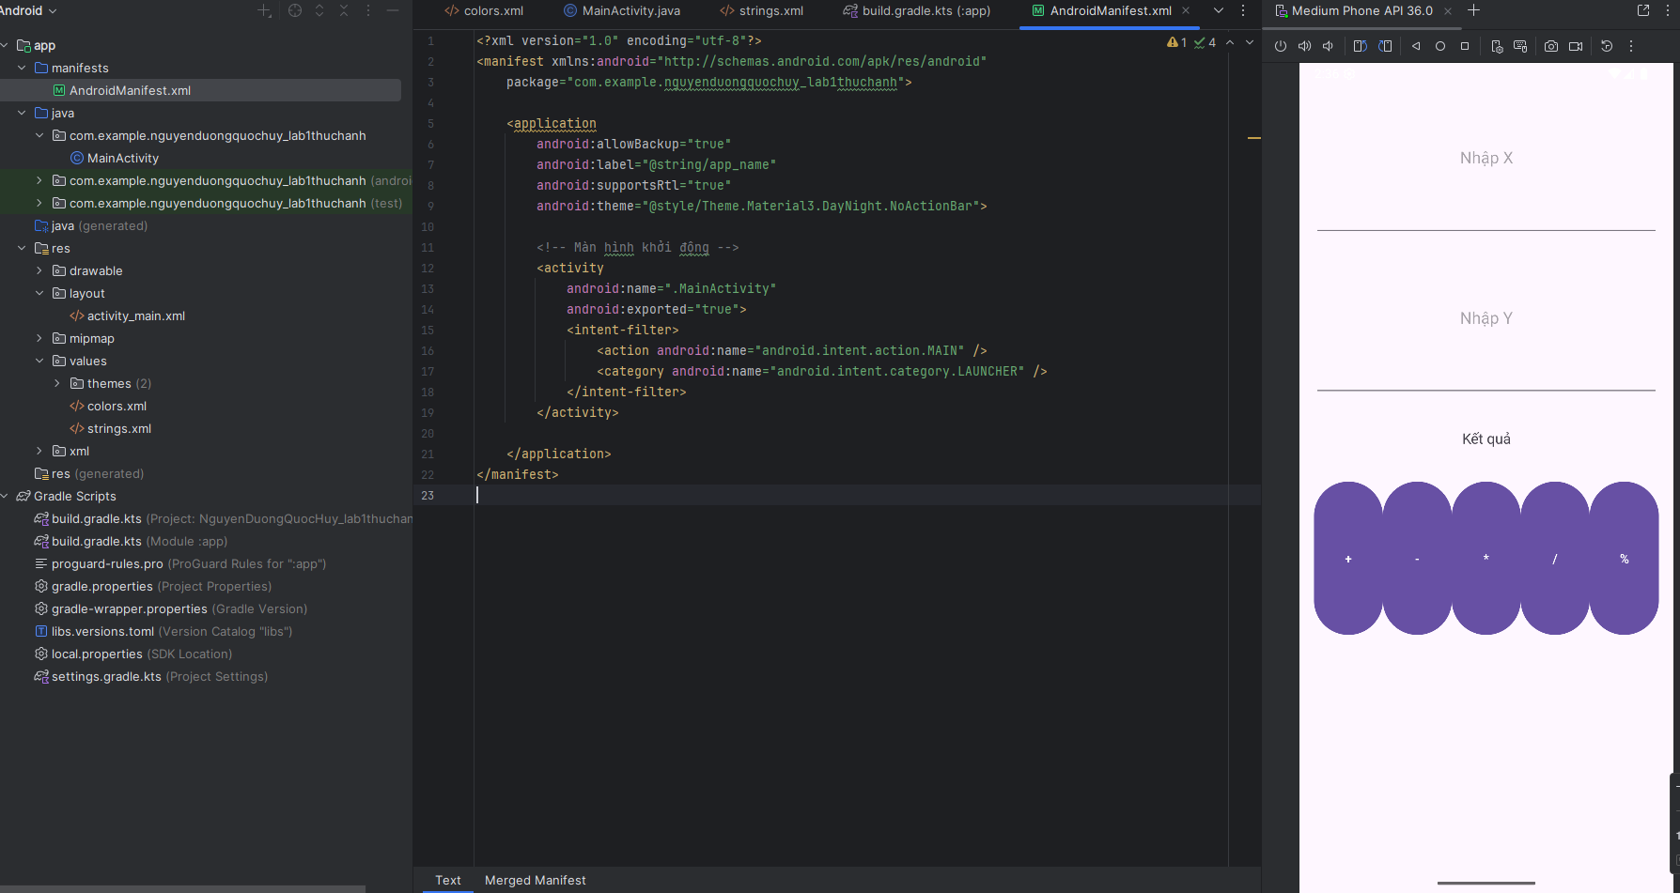

**5.Làm thêm để đẹp hơn**

Thêm Layout

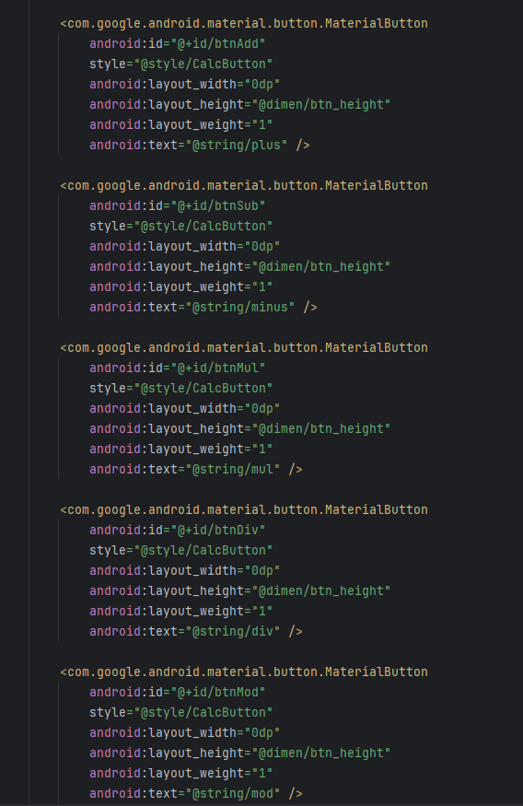

Thêm dimens

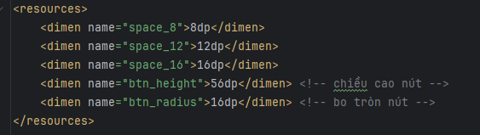

Thêm Strings

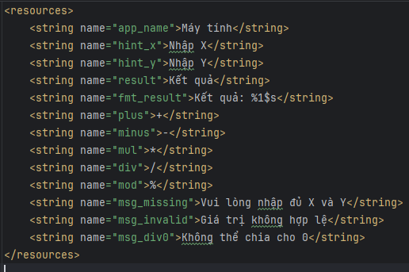

Thêm Styles

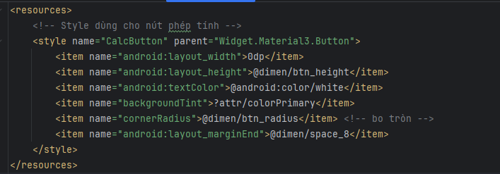

**Kết quả:**

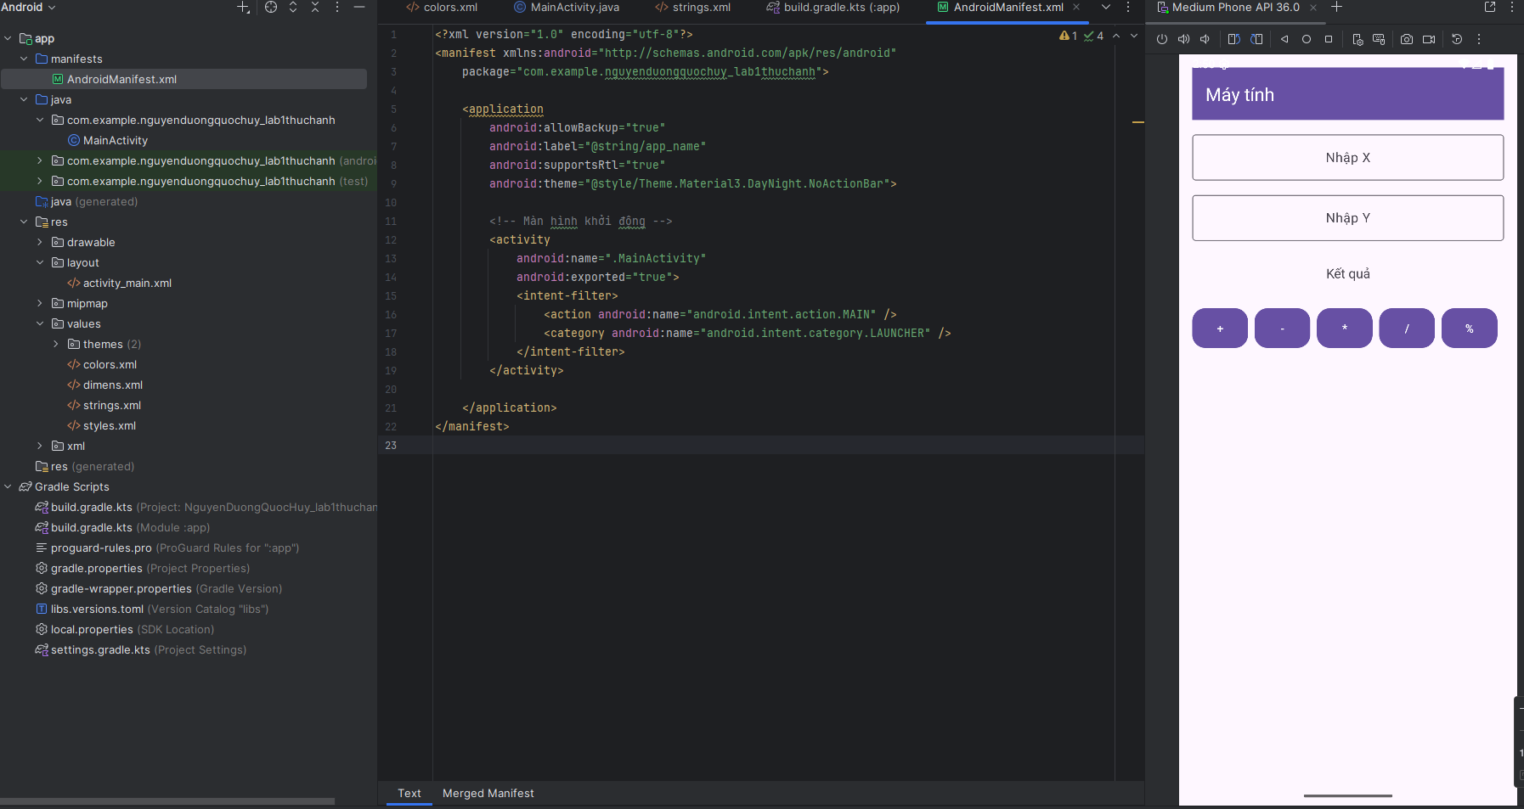

**Bài tập 2:** Xây dựng một ứng dụng cho phép mỗi khi người dùng nhấn nút thì xuất một số ngẫu nhiên ra màn hình (trái). Cải tiến để minh họa tung khối xúc xắc 6 mặt như hình phải.

**1.app/src/main/res/layout/activity_main.xml**

<?xml version="1.0" encoding="utf-8"?>

<LinearLayout xmlns:android="http://schemas.android.com/apk/res/android"

xmlns:app="http://schemas.android.com/apk/res-auto"

android:layout_width="match_parent"

android:layout_height="match_parent"

android:orientation="vertical"

android:padding="16dp">

<com.google.android.material.appbar.MaterialToolbar

android:id="@+id/toolbar"

android:layout_width="match_parent"

android:layout_height="?attr/actionBarSize"

android:background="?attr/colorPrimary"

app:title="@string/app_name"

app:titleTextColor="@android:color/white" />

<TextView

android:id="@+id/tvDisplay"

android:layout_width="match_parent"

android:layout_height="0dp"

android:layout_weight="1"

android:gravity="center"

android:text="00"

android:textColor="#E53935"

android:textSize="64sp" />

<TextView

android:id="@+id/tvHint"

android:layout_width="match_parent"

android:layout_height="wrap_content"

android:gravity="center"

android:text="@string/hint_text"

android:textSize="14sp"

android:paddingTop="8dp"

android:paddingBottom="8dp" />

<com.google.android.material.button.MaterialButton

android:id="@+id/btnAction"

style="@style/Widget.Material3.Button"

android:layout_width="match_parent"

android:layout_height="48dp"

android:text="@string/random_number"

android:textAllCaps="true"

android:textColor="@android:color/white"

app:backgroundTint="?attr/colorPrimary" />

</LinearLayout>

**2.app/src/main/java/com/example/nguyenduongquochuy_lab1thuchanh/MainActivity.java**

package com.example.nguyenduongquochuy_lab1thuchanh;  
  
import android.os.Bundle;  
import android.widget.TextView;  
import androidx.appcompat.app.AppCompatActivity;  
import com.google.android.material.appbar.MaterialToolbar;  
import com.google.android.material.button.MaterialButton;  
  
import java.util.Random;  
  
public class MainActivity extends AppCompatActivity {  
  
 private TextView tvDisplay;  
 private MaterialButton btnAction;  
 private final Random rnd = new Random();  
  
 private static final String[] *DICE* = {"\u2680","\u2681","\u2682","\u2683","\u2684","\u2685"};  
  
 @Override  
 protected void onCreate(Bundle savedInstanceState) {  
 super.onCreate(savedInstanceState);  
 setContentView(R.layout.*activity_main*);  
  
 MaterialToolbar toolbar = findViewById(R.id.*toolbar*);  
 setSupportActionBar(toolbar);  
 tvDisplay = findViewById(R.id.*tvDisplay*);  
 btnAction = findViewById(R.id.*btnAction*);  
 btnAction.setOnClickListener(v -> {  
 int val = rnd.nextInt(100);   
 String s = String.*format*("%02d", val);   
 tvDisplay.setText(s);  
 });  
  
 btnAction.setOnLongClickListener(v -> {  
 int face = rnd.nextInt(6);   
 tvDisplay.setText(*DICE*[face]);   
 return true;   
 });  
 }  
}

**3.app/src/main/res/values/strings.xml**

<resources>  
 <string name="app_name">Randomly</string>  
 <string name="random_number">RANDOM NUMBER</string>  
 <string name="hint_text">Nhấn nút để sinh số ngẫu nhiên (00–99). Giữ nút để tung xúc xắc ⚀–⚅.</string>  
</resources>

**4.app/src/main/AndroidManifest.xml**

<?xml version="1.0" encoding="utf-8"?>  
<manifest xmlns:android="http://schemas.android.com/apk/res/android"  
 package="com.example.nguyenduongquochuy_lab1thuchanh">  
  
 <application  
 android:allowBackup="true"  
 android:label="@string/app_name"  
 android:supportsRtl="true"  
 android:theme="@style/Theme.Material3.DayNight.NoActionBar">  
  
 <activity  
 android:name=".MainActivity"  
 android:exported="true">  
 <intent-filter>  
 <action android:name="android.intent.action.MAIN"/>  
 <category android:name="android.intent.category.LAUNCHER"/>  
 </intent-filter>  
 </activity>  
  
 </application>  
</manifest>

**Kết quả:**

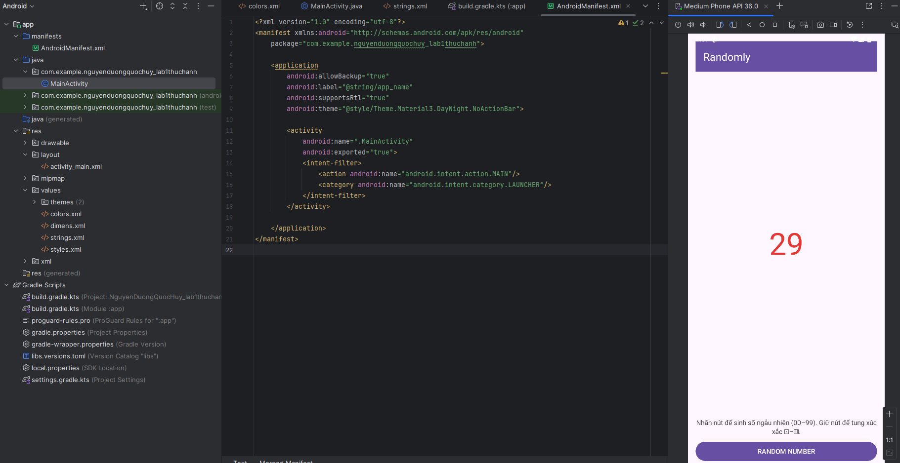

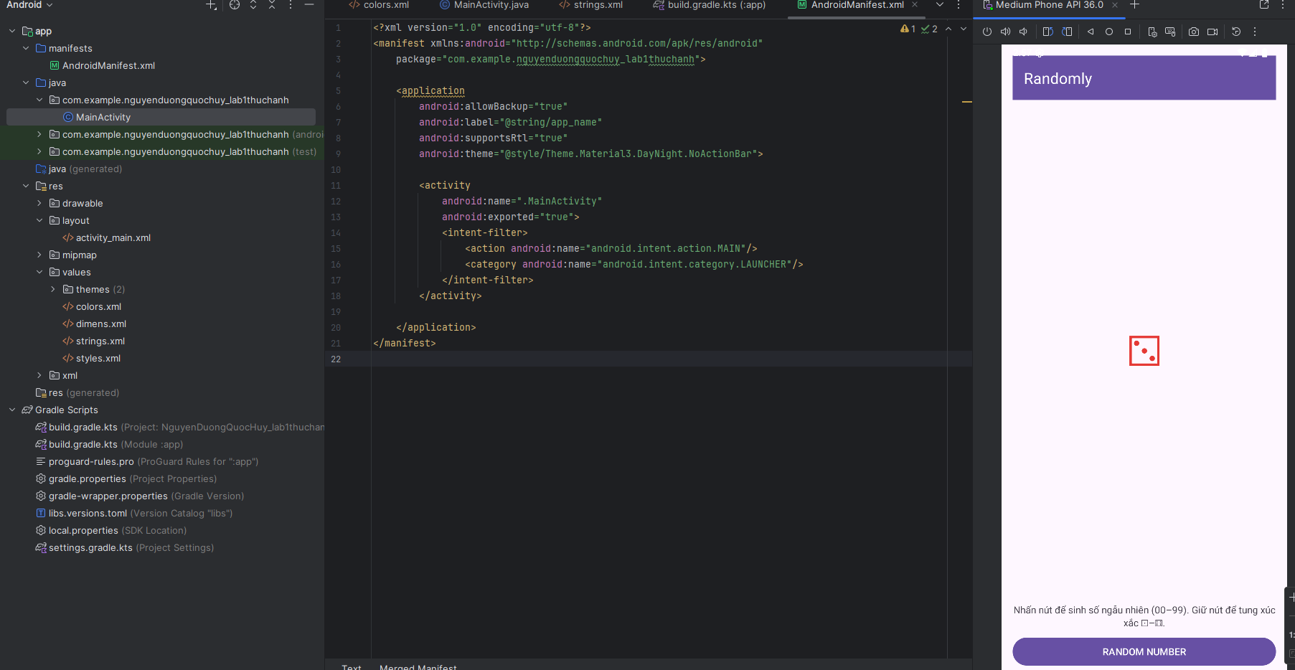

**Bài tập 3:** Viết chương trình cho phép gọi, nhắn tin trên Hệ điều hành Android.

**1.** **app/src/main/res/layout/activity_main.xml**

<?xml version="1.0" encoding="utf-8"?>  
<LinearLayout xmlns:android="http://schemas.android.com/apk/res/android"  
 xmlns:app="http://schemas.android.com/apk/res-auto"  
 android:layout_width="match_parent"  
 android:layout_height="match_parent"  
 android:orientation="vertical"  
 android:padding="16dp">  
  
 <TextView  
 android:layout_width="match_parent"  
 android:layout_height="wrap_content"  
 android:text="Gọi và Nhắn tin"  
 android:textSize="20sp"  
 android:textStyle="bold"  
 android:paddingBottom="8dp" />  
  
 <EditText  
 android:id="@+id/edtPhone"  
 android:layout_width="match_parent"  
 android:layout_height="wrap_content"  
 android:hint="Nhập số điện thoại"  
 android:inputType="phone"  
 android:maxLines="1"  
 android:padding="12dp" />  
  
 <EditText  
 android:id="@+id/edtMessage"  
 android:layout_width="match_parent"  
 android:layout_height="120dp"  
 android:hint="Nội dung tin nhắn (tùy chọn)"  
 android:gravity="top|start"  
 android:inputType="textMultiLine"  
 android:padding="12dp"  
 android:layout_marginTop="12dp" />  
  
 <LinearLayout  
 android:layout_width="match_parent"  
 android:layout_height="wrap_content"  
 android:orientation="horizontal"  
 android:layout_marginTop="16dp"  
 android:weightSum="2">  
  
 <com.google.android.material.button.MaterialButton  
 android:id="@+id/btnCall"  
 style="@style/Widget.Material3.Button"  
 android:layout_width="0dp"  
 android:layout_height="48dp"  
 android:layout_weight="1"  
 android:text="GỌI ĐIỆN"  
 android:textAllCaps="true"  
 android:textColor="@android:color/white"  
 app:backgroundTint="?attr/colorPrimary" />  
  
 <Space  
 android:layout_width="12dp"  
 android:layout_height="1dp" />  
  
 <com.google.android.material.button.MaterialButton  
 android:id="@+id/btnSms"  
 style="@style/Widget.Material3.Button"  
 android:layout_width="0dp"  
 android:layout_height="48dp"  
 android:layout_weight="1"  
 android:text="NHẮN TIN"  
 android:textAllCaps="true"  
 android:textColor="@android:color/white"  
 app:backgroundTint="?attr/colorPrimary" />  
 </LinearLayout>  
  
</LinearLayout>

**2.app/src/main/java/com/example/nguyenduongquochuy_lab1thuchanh/MainActivity.java**

package com.example.nguyenduongquochuy_lab1thuchanh;  
  
import android.content.Intent;  
import android.net.Uri;  
import android.os.Bundle;  
import android.text.TextUtils;  
import android.widget.EditText;  
import android.widget.Toast;  
  
import androidx.appcompat.app.AppCompatActivity;  
  
import com.google.android.material.button.MaterialButton;  
  
public class MainActivity extends AppCompatActivity {  
  
 private EditText edtPhone, edtMessage;  
 private MaterialButton btnCall, btnSms;  
  
 @Override  
 protected void onCreate(Bundle savedInstanceState) {  
 super.onCreate(savedInstanceState);  
 setContentView(R.layout.*activity_main*);  
 initControl();  
 }  
  
 private void initControl() {  
 edtPhone = findViewById(R.id.*edtPhone*);  
 edtMessage = findViewById(R.id.*edtMessage*);  
 btnCall = findViewById(R.id.*btnCall*);  
 btnSms = findViewById(R.id.*btnSms*);  
  
 btnCall.setOnClickListener(v -> {  
 String phone = normalizePhone(edtPhone.getText().toString());  
 if (TextUtils.*isEmpty*(phone)) {  
 toast("Vui lòng nhập số điện thoại");  
 return;  
 }  
 Intent dial = new Intent(Intent.*ACTION_DIAL*);  
 dial.setData(Uri.*parse*("tel:" + phone));  
 startActivity(dial);  
 });  
  
 btnSms.setOnClickListener(v -> {  
 String phone = normalizePhone(edtPhone.getText().toString());  
 if (TextUtils.*isEmpty*(phone)) {  
 toast("Vui lòng nhập số điện thoại");  
 return;  
 }  
 String body = edtMessage.getText().toString();  
  
 Intent sms = new Intent(Intent.*ACTION_SENDTO*);  
 sms.setData(Uri.*parse*("smsto:" + phone)); // chỉ các app SMS xử lý  
 if (!TextUtils.*isEmpty*(body)) {  
 sms.putExtra("sms_body", body);  
 }  
 startActivity(sms);  
 });  
 }  
  
 private String normalizePhone(String raw) {  
 if (raw == null) return "";  
 raw = raw.trim();  
 if (raw.startsWith("+")) {  
 return "+" + raw.substring(1).replaceAll("[^0-9]", "");  
 } else {  
 return raw.replaceAll("[^0-9]", "");  
 }  
 }  
  
 private void toast(String s) { Toast.*makeText*(this, s, Toast.*LENGTH_SHORT*).show(); }  
}

**3.app/src/main/res/values/strings.xml**

<resources>

<string name="app_name">Call và SMS</string>

</resources>

**4. app/src/main/AndroidManifest.xml**

<?xml version="1.0" encoding="utf-8"?>  
<manifest xmlns:android="http://schemas.android.com/apk/res/android"  
 package="com.example.nguyenduongquochuy_lab1thuchanh">  
  
 <application  
 android:allowBackup="true"  
 android:label="@string/app_name"  
 android:supportsRtl="true"  
 android:theme="@style/Theme.Material3.DayNight.NoActionBar">  
  
 <activity  
 android:name=".MainActivity"  
 android:exported="true">  
 <intent-filter>  
 <action android:name="android.intent.action.MAIN"/>  
 <category android:name="android.intent.category.LAUNCHER"/>  
 </intent-filter>  
 </activity>  
  
 </application>  
</manifest>

**Kết quả:**

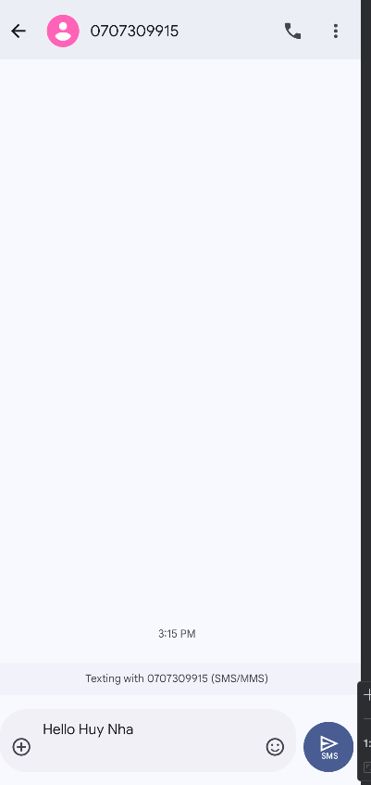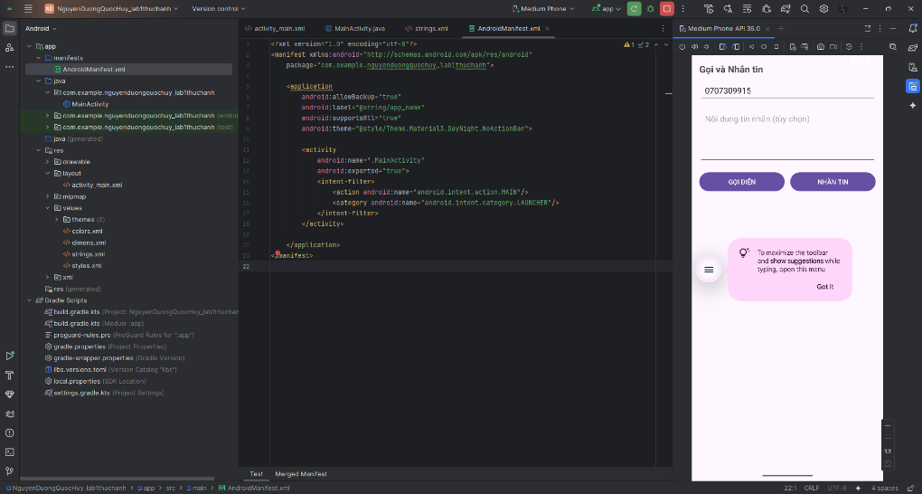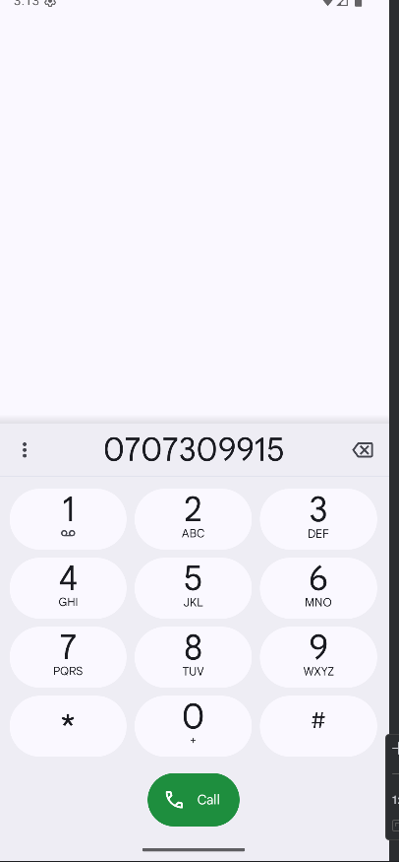

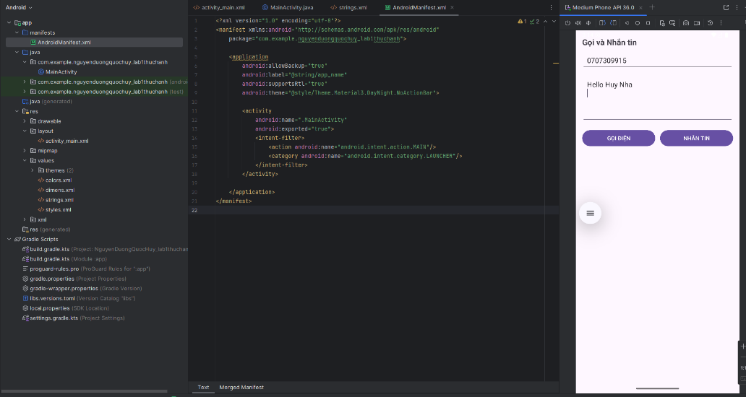

**LAB 2**

**Bài tập 1:** Trong bài luyện tập 1, viết code để mỗi khi chạy lên sẽ ra một màu nền khác nhau và 1 icon khác nhau.

**1.app/src/main/res/layout/activity_main.xml**

<?xml version="1.0" encoding="utf-8"?>

<LinearLayout xmlns:android="http://schemas.android.com/apk/res/android"

android:id="@+id/rootLayout"

android:layout_width="match_parent"

android:layout_height="match_parent"

android:orientation="vertical"

android:gravity="center"

android:padding="24dp">

<ImageView

android:id="@+id/imgIcon"

android:layout_width="128dp"

android:layout_height="128dp"

android:contentDescription="@string/random_icon" />

<TextView

android:id="@+id/tvInfo"

android:layout_width="wrap_content"

android:layout_height="wrap_content"

android:layout_marginTop="16dp"

android:textSize="16sp"

android:textColor="@android:color/white" />

</LinearLayout>

**2.app/src/main/java/com/example/nguyenduongquochuy_lab1thuchanh/MainActivity.java**

package com.example.nguyenduongquochuy_lab1thuchanh;  
  
import android.content.SharedPreferences;  
import android.graphics.Color;  
import android.os.Bundle;  
import android.widget.ImageView;  
import android.widget.LinearLayout;  
import android.widget.TextView;  
  
import androidx.appcompat.app.AppCompatActivity;  
  
import java.util.Random;  
  
public class MainActivity extends AppCompatActivity {  
  
 private LinearLayout root;  
 private ImageView imgIcon;  
 private TextView tvInfo;  
  
 private final Random rnd = new Random();  
  
 private final int[] COLORS = new int[]{  
 Color.*parseColor*("#FF6F61"), // đỏ cam  
 Color.*parseColor*("#26A69A"), // teal  
 Color.*parseColor*("#5C6BC0"), // indigo  
 Color.*parseColor*("#EC407A"), // hồng  
 Color.*parseColor*("#29B6F6"), // xanh dương nhạt  
 Color.*parseColor*("#FFB300") // vàng  
 };  
  
 private final int[] ICONS = new int[]{  
 android.R.drawable.*ic_menu_camera*,  
 android.R.drawable.*ic_menu_call*,  
 android.R.drawable.*ic_menu_compass*,  
 android.R.drawable.*ic_dialog_email*,  
 android.R.drawable.*ic_menu_directions*,  
 android.R.drawable.*ic_dialog_info* };  
 private final String[] ICON_NAMES = new String[]{  
 "ic_menu_camera", "ic_menu_call", "ic_menu_compass",  
 "ic_dialog_email", "ic_menu_directions", "ic_dialog_info"  
 };  
  
 @Override  
 protected void onCreate(Bundle savedInstanceState) {  
 super.onCreate(savedInstanceState);  
 setContentView(R.layout.*activity_main*);  
  
 root = findViewById(R.id.*rootLayout*);  
 imgIcon = findViewById(R.id.*imgIcon*);  
 tvInfo = findViewById(R.id.*tvInfo*);  
  
 applyRandomThemePerRun();  
 }  
private void applyRandomThemePerRun() {  
 SharedPreferences sp = getSharedPreferences("random_theme", *MODE_PRIVATE*);  
 int lastColorIdx = sp.getInt("color_idx", -1);  
 int lastIconIdx = sp.getInt("icon_idx", -1);  
  
 int cIdx = rnd.nextInt(COLORS.length);  
 int iIdx = rnd.nextInt(ICONS.length);  
  
 if (COLORS.length > 1) {  
 while (cIdx == lastColorIdx) cIdx = rnd.nextInt(COLORS.length);  
 }  
 if (ICONS.length > 1) {  
 while (iIdx == lastIconIdx) iIdx = rnd.nextInt(ICONS.length);  
 }  
  
 root.setBackgroundColor(COLORS[cIdx]);  
 imgIcon.setImageResource(ICONS[iIdx]);  
 tvInfo.setText(getString(R.string.*info_format*, cIdx + 1, ICON_NAMES[iIdx]));  
  
 sp.edit().putInt("color_idx", cIdx).putInt("icon_idx", iIdx).apply();  
 }  
}

**3.app/src/main/res/values/strings.xml**

<resources>  
 <string name="app_name">Random Theme</string>  
 <string name="random_icon">Icon ngẫu nhiên</string>  
 <string name="info_format">Màu #%1$d • Icon: %2$s</string>  
</resources>

**4.app/src/main/AndroidManifest.xml**

<?xml version="1.0" encoding="utf-8"?>  
<manifest xmlns:android="http://schemas.android.com/apk/res/android"  
 package="com.example.nguyenduongquochuy_lab1thuchanh">  
  
 <application  
 android:allowBackup="true"  
 android:label="@string/app_name"  
 android:supportsRtl="true"  
 android:theme="@style/Theme.Material3.DayNight.NoActionBar">  
 <activity  
 android:name=".MainActivity"  
 android:exported="true">  
 <intent-filter>  
 <action android:name="android.intent.action.MAIN"/>  
 <category android:name="android.intent.category.LAUNCHER"/>  
 </intent-filter>  
 </activity>  
 </application>  
</manifest>

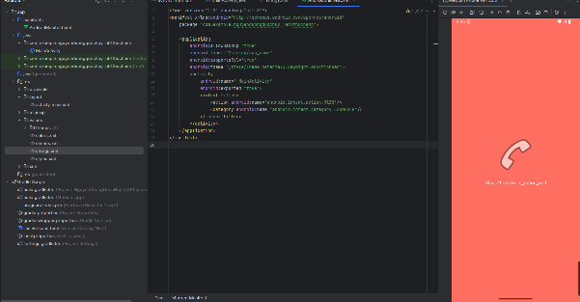**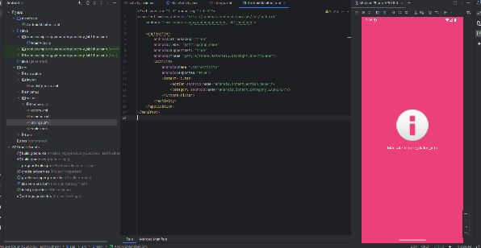Kết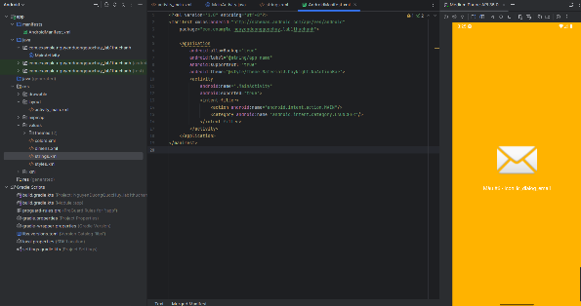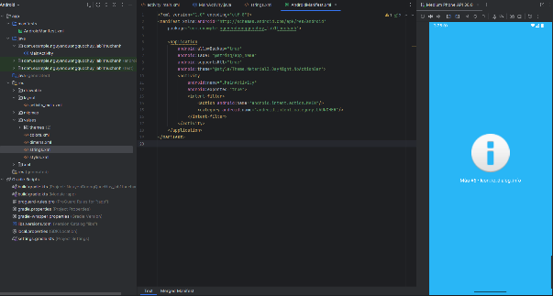 quả:**

**Bài tập 2:** Trong bài luyện tập 2, sử dụng Custom ProgressBar để làm giao diện đẹp hơn.

**1.app/src/main/res/layout/activity_main.xml**

<?xml version="1.0" encoding="utf-8"?>  
<LinearLayout xmlns:android="http://schemas.android.com/apk/res/android"  
 xmlns:app="http://schemas.android.com/apk/res-auto"  
 android:layout_width="match_parent"  
 android:layout_height="match_parent"  
 android:orientation="vertical"  
 android:padding="16dp">  
  
 <com.google.android.material.appbar.MaterialToolbar  
 android:id="@+id/toolbar"  
 android:layout_width="match_parent"  
 android:layout_height="?attr/actionBarSize"  
 android:background="?attr/colorPrimary"  
 app:title="@string/app_name"  
 app:titleTextColor="@android:color/white" />  
  
 <TextView  
 android:id="@+id/tvPercent"  
 android:layout_width="match_parent"  
 android:layout_height="wrap_content"  
 android:text="0%"  
 android:textStyle="bold"  
 android:textSize="20sp"  
 android:gravity="center"  
 android:layout_marginTop="16dp" />  
  
 <ProgressBar  
 android:id="@+id/progress"  
 style="?android:attr/progressBarStyleHorizontal"  
 android:layout_width="match_parent"  
 android:layout_height="20dp"  
 android:layout_marginTop="12dp"  
 android:max="100"  
 android:progress="0"  
 android:progressDrawable="@drawable/progress_horizontal" />  
  
 <LinearLayout  
 android:layout_width="match_parent"  
 android:layout_height="wrap_content"  
 android:orientation="horizontal"  
 android:layout_marginTop="16dp"  
 android:weightSum="3">  
  
 <com.google.android.material.button.MaterialButton  
 android:id="@+id/btnStart"  
 style="@style/Widget.Material3.Button"  
 android:layout_width="0dp"  
 android:layout_height="48dp"  
 android:layout_weight="1"  
 android:text="@string/start"  
 android:textColor="@android:color/white"  
 app:backgroundTint="?attr/colorPrimary" />  
  
 <Space  
 android:layout_width="8dp"  
 android:layout_height="1dp" />  
  
 <com.google.android.material.button.MaterialButton  
 android:id="@+id/btnPause"  
 style="@style/Widget.Material3.Button"  
 android:layout_width="0dp"  
 android:layout_height="48dp"  
 android:layout_weight="1"  
 android:text="@string/pause"  
 android:textColor="@android:color/white"  
 app:backgroundTint="?attr/colorPrimary" />  
  
 <Space  
 android:layout_width="8dp"  
 android:layout_height="1dp" />  
  
 <com.google.android.material.button.MaterialButton  
 android:id="@+id/btnReset"  
 style="@style/Widget.Material3.Button"  
 android:layout_width="0dp"  
 android:layout_height="48dp"  
 android:layout_weight="1"  
 android:text="@string/reset"  
 android:textColor="@android:color/white"  
 app:backgroundTint="?attr/colorPrimary" />  
 </LinearLayout>  
  
</LinearLayout>

**2.app/src/main/java/com/example/nguyenduongquochuy_lab1thuchanh/MainActivity.java**

package com.example.nguyenduongquochuy_lab1thuchanh;  
  
import android.os.Bundle;  
import android.os.Handler;  
import android.os.Looper;  
import android.widget.ProgressBar;  
import android.widget.TextView;  
  
import androidx.appcompat.app.AppCompatActivity;  
  
import com.google.android.material.appbar.MaterialToolbar;  
import com.google.android.material.button.MaterialButton;  
  
public class MainActivity extends AppCompatActivity {  
  
 private ProgressBar progress;  
 private TextView tvPercent;  
 private MaterialButton btnStart, btnPause, btnReset;  
  
 private final Handler handler = new Handler(Looper.*getMainLooper*());  
 private boolean isRunning = false;  
  
 private final Runnable tick = new Runnable() {  
 @Override public void run() {  
 int p = progress.getProgress();  
 if (p < progress.getMax()) {  
 progress.setProgress(p + 1);  
 tvPercent.setText((p + 1) + "%");  
 handler.postDelayed(this, 50); // tốc độ chạy (ms)  
 } else {  
 isRunning = false;  
 }  
 }  
 };  
  
 @Override  
 protected void onCreate(Bundle savedInstanceState) {  
 super.onCreate(savedInstanceState);  
 setContentView(R.layout.*activity_main*);  
  
 MaterialToolbar toolbar = findViewById(R.id.*toolbar*);  
 setSupportActionBar(toolbar);  
  
 progress = findViewById(R.id.*progress*);  
 tvPercent = findViewById(R.id.*tvPercent*);  
 btnStart = findViewById(R.id.*btnStart*);  
 btnPause = findViewById(R.id.*btnPause*);  
 btnReset = findViewById(R.id.*btnReset*);  
  
 btnStart.setOnClickListener(v -> startProgress());  
 btnPause.setOnClickListener(v -> pauseProgress());  
 btnReset.setOnClickListener(v -> resetProgress());  
 }  
  
 private void startProgress() {  
 if (!isRunning) {  
 isRunning = true;  
 handler.post(tick);  
 }  
 }  
  
 private void pauseProgress() {  
 isRunning = false;  
 handler.removeCallbacks(tick);  
 }  
  
 private void resetProgress() {  
 pauseProgress();  
 progress.setProgress(0);  
 tvPercent.setText("0%");  
 }  
  
 @Override  
 protected void onDestroy() {  
 super.onDestroy();  
 handler.removeCallbacksAndMessages(null);  
 }  
}

**3.app/src/main/res/drawable/progress_horizontal.xml**

<?xml version="1.0" encoding="utf-8"?>  
<layer-list xmlns:android="http://schemas.android.com/apk/res/android">  
  
 <item android:id="@android:id/background">  
 <shape android:shape="rectangle">  
 <corners android:radius="12dp" />  
 <solid android:color="#ECEFF1" />  
 </shape>  
 </item>  
  
 <item android:id="@android:id/progress">  
 <clip>  
 <shape android:shape="rectangle">  
 <corners android:radius="12dp" />  
 <gradient  
 android:type="linear"  
 android:angle="0"  
 android:startColor="#FF6FB1"  
 android:centerColor="#A66BFF"  
 android:endColor="#6B8CFF" />  
 </shape>  
 </clip>  
 </item>  
  
</layer-list>

**4.** **app/src/main/res/values/strings.xml**

<resources>

<string name="app_name">Custom Progress</string>

<string name="start">Start</string>

<string name="pause">Pause</string>

<string name="reset">Reset</string>

</resources>

**5.app/src/main/AndroidManifest.xml**

<?xml version="1.0" encoding="utf-8"?>  
<manifest xmlns:android="http://schemas.android.com/apk/res/android"  
 package="com.example.nguyenduongquochuy_lab1thuchanh">  
  
 <application  
 android:allowBackup="true"  
 android:label="@string/app_name"  
 android:supportsRtl="true"  
 android:theme="@style/Theme.Material3.DayNight.NoActionBar">  
  
 <activity  
 android:name=".MainActivity"  
 android:exported="true">  
 <intent-filter>  
 <action android:name="android.intent.action.MAIN"/>  
 <category android:name="android.intent.category.LAUNCHER"/>  
 </intent-filter>  
 </activity>  
  
 </application>  
</manifest>

**Kết quả:**

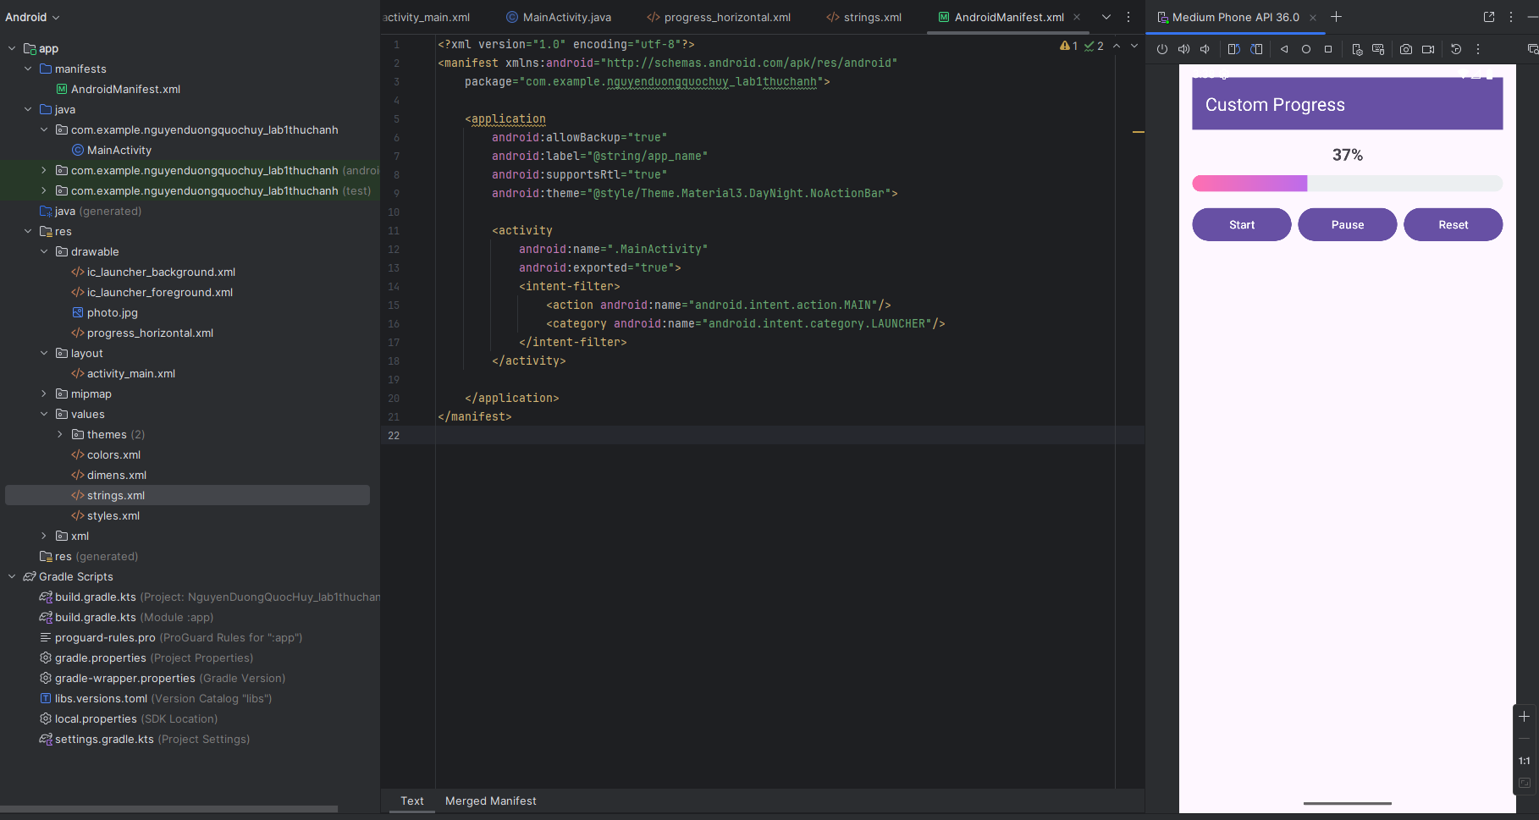

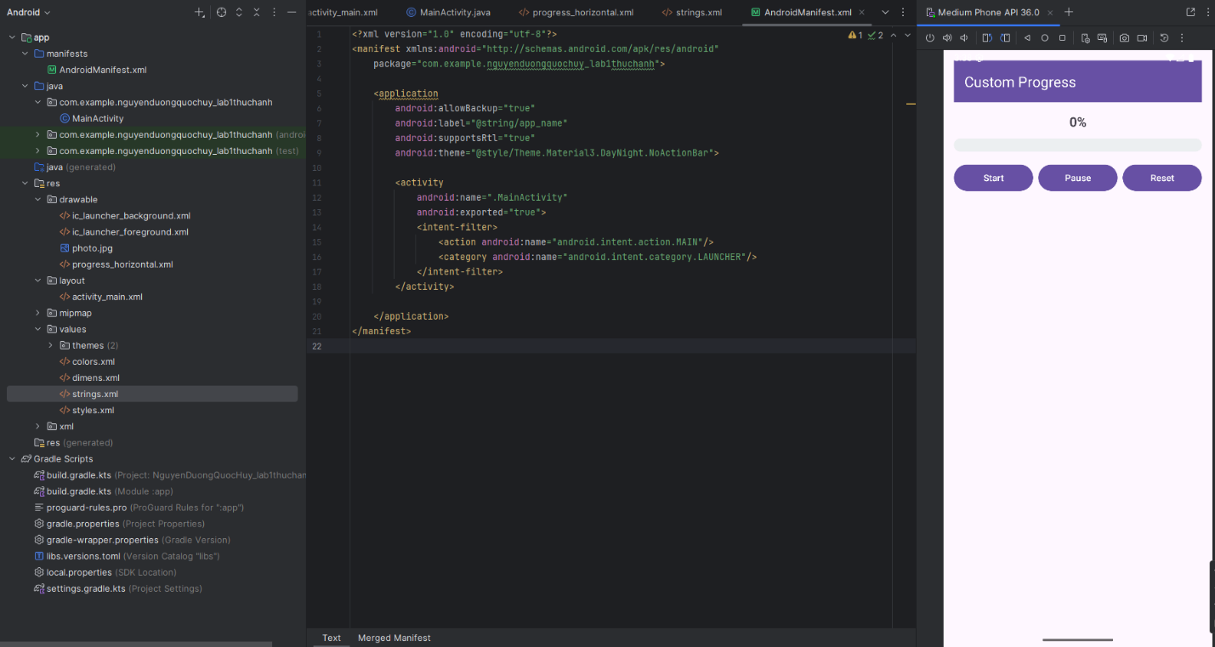

**Bài tập 3:** Lập trình để khi bấm vào icon thì chuyển về cuộc gọi, sử dụng Intent.

**1.app/src/main/res/layout/activity_main.xml**

<?xml version="1.0" encoding="utf-8"?>  
<LinearLayout xmlns:android="http://schemas.android.com/apk/res/android"  
 android:id="@+id/root"  
 android:layout_width="match_parent"  
 android:layout_height="match_parent"  
 android:gravity="center"  
 android:orientation="vertical"  
 android:padding="24dp">  
  
 <!-- Icon điện thoại (dùng sẵn icon hệ thống, không cần thêm asset) -->  
 <ImageView  
 android:id="@+id/imgCall"  
 android:layout_width="128dp"  
 android:layout_height="128dp"  
 android:src="@android:drawable/ic_menu_call"  
 android:contentDescription="@string/desc_call_icon" />  
  
 <TextView  
 android:id="@+id/tvHint"  
 android:layout_width="wrap_content"  
 android:layout_height="wrap_content"  
 android:text="@string/hint_tap_to_call"  
 android:textSize="16sp"  
 android:layout_marginTop="12dp" />  
  
</LinearLayout>

**2.app/src/main/java/com/example/nguyenduongquochuy_lab1thuchanh/MainActivity.java**

package com.example.nguyenduongquochuy_lab1thuchanh;  
  
import android.content.Intent;  
import android.net.Uri;  
import android.os.Bundle;  
import android.widget.ImageView;  
  
import androidx.appcompat.app.AppCompatActivity;  
  
public class MainActivity extends AppCompatActivity {  
  
 private ImageView imgCall;  
  
 @Override  
 protected void onCreate(Bundle savedInstanceState) {  
 super.onCreate(savedInstanceState);  
 setContentView(R.layout.*activity_main*);  
  
 imgCall = findViewById(R.id.*imgCall*);  
  
 imgCall.setOnClickListener(v -> {  
 String phone = getString(R.string.*sample_phone*); // đổi số ở strings.xml  
 Intent dial = new Intent(Intent.*ACTION_DIAL*, Uri.*parse*("tel:" + phone));  
 startActivity(dial);  
 });  
 }  
}

**3.app/src/main/res/values/strings.xml**

<resources>  
 <string name="app_name">Call by Icon</string>  
 <string name="desc_call_icon">Icon gọi điện</string>  
 <string name="hint_tap_to_call">Chạm vào icon để gọi</string>  
 <string name="sample_phone">0707309915</string>  
</resources>

**4.app/src/main/AndroidManifest.xml**

<?xml version="1.0" encoding="utf-8"?>  
<manifest xmlns:android="http://schemas.android.com/apk/res/android"  
 package="com.example.nguyenduongquochuy_lab1thuchanh">  
  
 <application  
 android:allowBackup="true"  
 android:label="@string/app_name"  
 android:supportsRtl="true"  
 android:theme="@style/Theme.Material3.DayNight.NoActionBar">  
  
 <activity  
 android:name=".MainActivity"  
 android:exported="true">  
 <intent-filter>  
 <action android:name="android.intent.action.MAIN"/>  
 <category android:name="android.intent.category.LAUNCHER"/>  
 </intent-filter>  
 </activity>  
  
 </application>  
</manifest>

**Kết quả:**

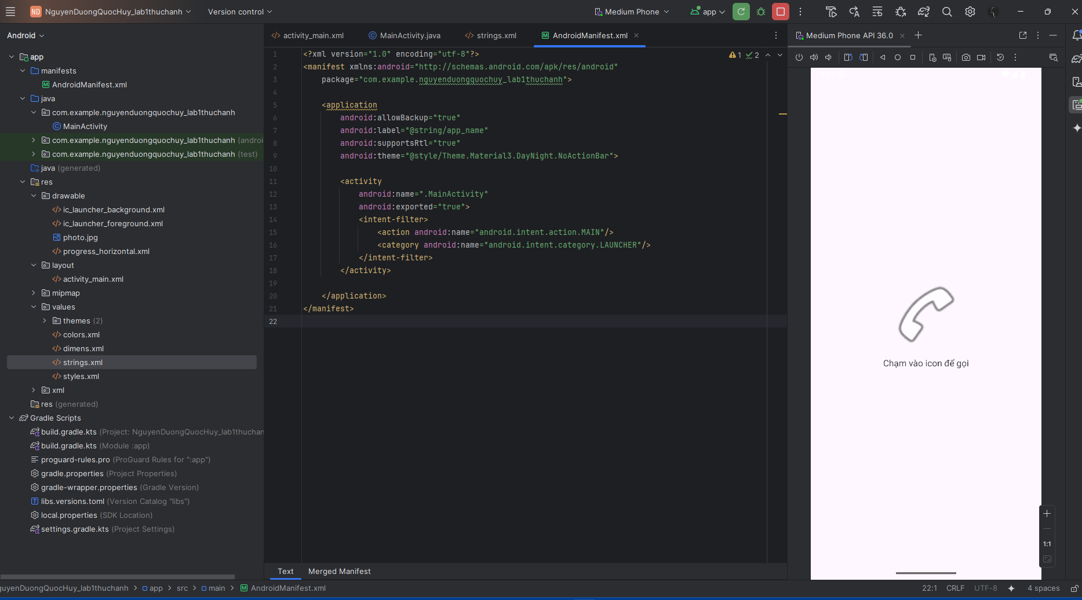

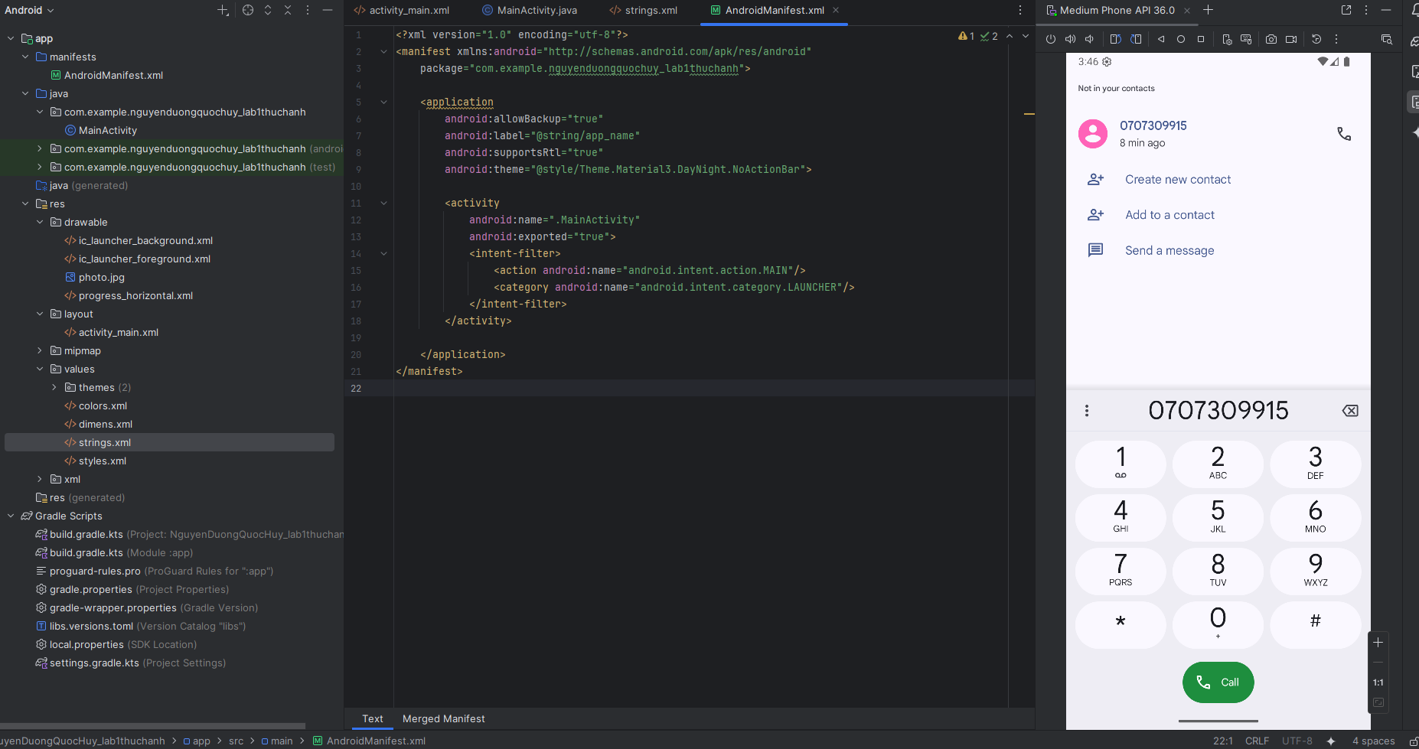

**Bài tập 4:** Tạo màn hình chính MainActivity để chuyển qua và chuyển về giữa các màn hình ở các phần luyện tập.

**1.app/src/main/res/layout/activity_main.xml**

<?xml version="1.0" encoding="utf-8"?>  
<LinearLayout xmlns:android="http://schemas.android.com/apk/res/android"  
 xmlns:app="http://schemas.android.com/apk/res-auto"  
 android:orientation="vertical"  
 android:padding="16dp"  
 android:layout_width="match_parent"  
 android:layout_height="match_parent">  
  
 <com.google.android.material.appbar.MaterialToolbar  
 android:id="@+id/toolbar"  
 android:layout_width="match_parent"  
 android:layout_height="?attr/actionBarSize"  
 android:background="?attr/colorPrimary"  
 app:title="@string/app_name"  
 app:titleTextColor="@android:color/white" />  
  
 <com.google.android.material.button.MaterialButton  
 android:id="@+id/btnEx1"  
 style="@style/Widget.Material3.Button"  
 android:layout_width="match_parent"  
 android:layout_height="56dp"  
 android:text="@string/ex1_title"  
 android:textAllCaps="false"  
 android:layout_marginTop="16dp" />  
  
 <com.google.android.material.button.MaterialButton  
 android:id="@+id/btnEx2"  
 style="@style/Widget.Material3.Button"  
 android:layout_width="match_parent"  
 android:layout_height="56dp"  
 android:text="@string/ex2_title"  
 android:textAllCaps="false"  
 android:layout_marginTop="12dp" />  
  
 <com.google.android.material.button.MaterialButton  
 android:id="@+id/btnEx3"  
 style="@style/Widget.Material3.Button"  
 android:layout_width="match_parent"  
 android:layout_height="56dp"  
 android:text="@string/ex3_title"  
 android:textAllCaps="false"  
 android:layout_marginTop="12dp" />  
  
</LinearLayout>

**2.app/src/main/java/com/example/nguyenduongquochuy_lab1thuchanh/MainActivity.java**

package com.example.nguyenduongquochuy_lab1thuchanh;  
  
import android.content.Intent;  
import android.os.Bundle;  
  
import androidx.appcompat.app.AppCompatActivity;  
  
import com.google.android.material.appbar.MaterialToolbar;  
import com.google.android.material.button.MaterialButton;  
  
public class MainActivity extends AppCompatActivity {  
  
 @Override  
 protected void onCreate(Bundle savedInstanceState) {  
 super.onCreate(savedInstanceState);  
 setContentView(R.layout.*activity_main*);  
  
 MaterialToolbar toolbar = findViewById(R.id.*toolbar*);  
 setSupportActionBar(toolbar);  
  
 MaterialButton btnEx1 = findViewById(R.id.*btnEx1*);  
 MaterialButton btnEx2 = findViewById(R.id.*btnEx2*);  
 MaterialButton btnEx3 = findViewById(R.id.*btnEx3*);  
  
 btnEx1.setOnClickListener(v ->  
 startActivity(new Intent(this, Ex1Activity.class)));  
  
 btnEx2.setOnClickListener(v ->  
 startActivity(new Intent(this, Ex2Activity.class)));  
  
 btnEx3.setOnClickListener(v ->  
 startActivity(new Intent(this, Ex3Activity.class)));  
 }  
}

**3.app/src/main/res/layout/activity_ex1.xml**

<?xml version="1.0" encoding="utf-8"?>  
<LinearLayout xmlns:android="http://schemas.android.com/apk/res/android"  
 android:id="@+id/rootEx1"  
 android:orientation="vertical"  
 android:gravity="center"  
 android:padding="24dp"  
 android:layout_width="match_parent"  
 android:layout_height="match_parent">  
  
 <com.google.android.material.appbar.MaterialToolbar  
 android:id="@+id/tbEx1"  
 android:layout_width="match_parent"  
 android:layout_height="?attr/actionBarSize"  
 android:background="?attr/colorPrimary" />  
  
 <ImageView  
 android:id="@+id/imgIcon"  
 android:layout_width="128dp"  
 android:layout_height="128dp"  
 android:layout_marginTop="24dp"  
 android:contentDescription="@string/random_icon" />  
  
 <TextView  
 android:id="@+id/tvInfo"  
 android:layout_width="wrap_content"  
 android:layout_height="wrap_content"  
 android:textColor="@android:color/white"  
 android:layout_marginTop="16dp"  
 android:textSize="16sp" />  
</LinearLayout>

**4.app/src/main/java/com/example/nguyenduongquochuy_lab1thuchanh/Ex1Activity.java**

package com.example.nguyenduongquochuy_lab1thuchanh;  
  
import android.content.SharedPreferences;  
import android.graphics.Color;  
import android.os.Bundle;  
import android.widget.ImageView;  
import android.widget.LinearLayout;  
import android.widget.TextView;  
  
import androidx.appcompat.app.AppCompatActivity;  
  
import com.google.android.material.appbar.MaterialToolbar;  
  
import java.util.Random;  
  
public class Ex1Activity extends AppCompatActivity {  
 private LinearLayout root;  
 private ImageView imgIcon;  
 private TextView tvInfo;  
  
 private final Random rnd = new Random();  
  
 private final int[] COLORS = new int[]{  
 Color.*parseColor*("#FF6F61"),  
 Color.*parseColor*("#26A69A"),  
 Color.*parseColor*("#5C6BC0"),  
 Color.*parseColor*("#EC407A"),  
 Color.*parseColor*("#29B6F6"),  
 Color.*parseColor*("#FFB300")  
 };  
  
 private final int[] ICONS = new int[]{  
 android.R.drawable.*ic_menu_camera*,  
 android.R.drawable.*ic_menu_call*,  
 android.R.drawable.*ic_menu_compass*,  
 android.R.drawable.*ic_dialog_email*,  
 android.R.drawable.*ic_menu_directions*,  
 android.R.drawable.*ic_dialog_info* };  
 private final String[] ICON_NAMES = new String[]{  
 "ic_menu_camera","ic_menu_call","ic_menu_compass",  
 "ic_dialog_email","ic_menu_directions","ic_dialog_info"  
 };  
  
 @Override  
 protected void onCreate(Bundle savedInstanceState) {  
 super.onCreate(savedInstanceState);  
 setContentView(R.layout.*activity_ex1*);  
  
 MaterialToolbar tb = findViewById(R.id.*tbEx1*);  
 tb.setTitle(getString(R.string.*ex1_title*));  
 setSupportActionBar(tb);  
 getSupportActionBar().setDisplayHomeAsUpEnabled(true);  
  
 root = findViewById(R.id.*rootEx1*);  
 imgIcon = findViewById(R.id.*imgIcon*);  
 tvInfo = findViewById(R.id.*tvInfo*);  
  
 applyRandomThemePerRun();  
 }  
  
 private void applyRandomThemePerRun() {  
 SharedPreferences sp = getSharedPreferences("random_theme", *MODE_PRIVATE*);  
 int lastColorIdx = sp.getInt("color_idx", -1);  
 int lastIconIdx = sp.getInt("icon_idx", -1);  
  
 int cIdx = rnd.nextInt(COLORS.length);  
 int iIdx = rnd.nextInt(ICONS.length);  
 if (COLORS.length > 1) while (cIdx == lastColorIdx) cIdx = rnd.nextInt(COLORS.length);  
 if (ICONS.length > 1) while (iIdx == lastIconIdx) iIdx = rnd.nextInt(ICONS.length);  
  
 root.setBackgroundColor(COLORS[cIdx]);  
 imgIcon.setImageResource(ICONS[iIdx]);  
 tvInfo.setText(getString(R.string.*info_format*, cIdx + 1, ICON_NAMES[iIdx]));  
  
 sp.edit().putInt("color_idx", cIdx).putInt("icon_idx", iIdx).apply();  
 }  
  
 @Override  
 public boolean onSupportNavigateUp() { finish(); return true; }  
}

**5.app/src/main/res/layout/activity_ex2.xml**

<?xml version="1.0" encoding="utf-8"?>  
<LinearLayout xmlns:android="http://schemas.android.com/apk/res/android"  
 android:orientation="vertical"  
 android:padding="16dp"  
 android:layout_width="match_parent"  
 android:layout_height="match_parent">  
  
 <com.google.android.material.appbar.MaterialToolbar  
 android:id="@+id/tbEx2"  
 android:layout_width="match_parent"  
 android:layout_height="?attr/actionBarSize"  
 android:background="?attr/colorPrimary" />  
  
 <TextView  
 android:id="@+id/tvPercent"  
 android:layout_width="match_parent"  
 android:layout_height="wrap_content"  
 android:text="0%"  
 android:textStyle="bold"  
 android:textSize="20sp"  
 android:gravity="center"  
 android:layout_marginTop="16dp" />  
  
 <ProgressBar  
 android:id="@+id/progress"  
 style="?android:attr/progressBarStyleHorizontal"  
 android:layout_width="match_parent"  
 android:layout_height="20dp"  
 android:layout_marginTop="12dp"  
 android:max="100"  
 android:progress="0"  
 android:progressDrawable="@drawable/progress_horizontal" />  
  
 <LinearLayout  
 android:layout_width="match_parent"  
 android:layout_height="wrap_content"  
 android:orientation="horizontal"  
 android:weightSum="3"  
 android:layout_marginTop="16dp">  
  
 <com.google.android.material.button.MaterialButton  
 android:id="@+id/btnStart"  
 style="@style/Widget.Material3.Button"  
 android:layout_width="0dp"  
 android:layout_height="48dp"  
 android:layout_weight="1"  
 android:text="@string/start"  
 android:textColor="@android:color/white" />  
  
 <Space android:layout_width="8dp" android:layout_height="1dp" />  
  
 <com.google.android.material.button.MaterialButton  
 android:id="@+id/btnPause"  
 style="@style/Widget.Material3.Button"  
 android:layout_width="0dp"  
 android:layout_height="48dp"  
 android:layout_weight="1"  
 android:text="@string/pause"  
 android:textColor="@android:color/white" />  
  
 <Space android:layout_width="8dp" android:layout_height="1dp" />  
  
 <com.google.android.material.button.MaterialButton  
 android:id="@+id/btnReset"  
 style="@style/Widget.Material3.Button"  
 android:layout_width="0dp"  
 android:layout_height="48dp"  
 android:layout_weight="1"  
 android:text="@string/reset"  
 android:textColor="@android:color/white" />  
 </LinearLayout>  
</LinearLayout>

**6.app/src/main/java/com/example/nguyenduongquochuy_lab1thuchanh/Ex2Activity.java**

package com.example.nguyenduongquochuy_lab1thuchanh;  
  
import android.os.Bundle;  
import android.os.Handler;  
import android.os.Looper;  
import android.widget.ProgressBar;  
import android.widget.TextView;  
  
import androidx.appcompat.app.AppCompatActivity;  
  
import com.google.android.material.appbar.MaterialToolbar;  
import com.google.android.material.button.MaterialButton;  
  
public class Ex2Activity extends AppCompatActivity {  
  
 private ProgressBar progress;  
 private TextView tvPercent;  
 private final Handler handler = new Handler(Looper.*getMainLooper*());  
 private boolean isRunning = false;  
  
 private final Runnable tick = new Runnable() {  
 @Override public void run() {  
 int p = progress.getProgress();  
 if (p < progress.getMax()) {  
 progress.setProgress(p + 1);  
 tvPercent.setText((p + 1) + "%");  
 handler.postDelayed(this, 50);  
 } else isRunning = false;  
 }  
 };  
  
 @Override  
 protected void onCreate(Bundle savedInstanceState) {  
 super.onCreate(savedInstanceState);  
 setContentView(R.layout.*activity_ex2*);  
  
 MaterialToolbar tb = findViewById(R.id.*tbEx2*);  
 tb.setTitle(getString(R.string.*ex2_title*));  
 setSupportActionBar(tb);  
 getSupportActionBar().setDisplayHomeAsUpEnabled(true);  
  
 progress = findViewById(R.id.*progress*);  
 tvPercent = findViewById(R.id.*tvPercent*);  
 MaterialButton btnStart = findViewById(R.id.*btnStart*);  
 MaterialButton btnPause = findViewById(R.id.*btnPause*);  
 MaterialButton btnReset = findViewById(R.id.*btnReset*);  
  
 btnStart.setOnClickListener(v -> startProgress());  
 btnPause.setOnClickListener(v -> pauseProgress());  
 btnReset.setOnClickListener(v -> resetProgress());  
 }  
  
 private void startProgress() { if (!isRunning) { isRunning = true; handler.post(tick); } }  
 private void pauseProgress() { isRunning = false; handler.removeCallbacks(tick); }  
 private void resetProgress() { pauseProgress(); progress.setProgress(0); tvPercent.setText("0%"); }  
  
 @Override protected void onDestroy() {  
 super.onDestroy();  
 handler.removeCallbacksAndMessages(null);  
 }  
  
 @Override public boolean onSupportNavigateUp() { finish(); return true; }  
}

**7.app/src/main/res/drawable/progress_horizontal.xml**

<?xml version="1.0" encoding="utf-8"?>  
<layer-list xmlns:android="http://schemas.android.com/apk/res/android">  
 <item android:id="@android:id/background">  
 <shape android:shape="rectangle">  
 <corners android:radius="12dp" />  
 <solid android:color="#ECEFF1" />  
 </shape>  
 </item>  
 <item android:id="@android:id/progress">  
 <clip>  
 <shape android:shape="rectangle">  
 <corners android:radius="12dp" />  
 <gradient  
 android:type="linear"  
 android:angle="0"  
 android:startColor="#FF6FB1"  
 android:centerColor="#A66BFF"  
 android:endColor="#6B8CFF" />  
 </shape>  
 </clip>  
 </item>  
</layer-list>

**8.app/src/main/res/layout/activity_ex3.xml**

<?xml version="1.0" encoding="utf-8"?>  
<LinearLayout xmlns:android="http://schemas.android.com/apk/res/android"  
 android:orientation="vertical"  
 android:gravity="center"  
 android:padding="24dp"  
 android:layout_width="match_parent"  
 android:layout_height="match_parent">  
  
 <com.google.android.material.appbar.MaterialToolbar  
 android:id="@+id/tbEx3"  
 android:layout_width="match_parent"  
 android:layout_height="?attr/actionBarSize"  
 android:background="?attr/colorPrimary" />  
  
 <ImageView  
 android:id="@+id/imgCall"  
 android:layout_width="128dp"  
 android:layout_height="128dp"  
 android:layout_marginTop="24dp"  
 android:src="@android:drawable/ic_menu_call"  
 android:contentDescription="@string/desc_call_icon" />  
  
 <TextView  
 android:id="@+id/tvHint"  
 android:layout_width="wrap_content"  
 android:layout_height="wrap_content"  
 android:text="@string/hint_tap_to_call"  
 android:textSize="16sp"  
 android:layout_marginTop="12dp" />  
</LinearLayout>

**9.app/src/main/java/com/example/nguyenduongquochuy_lab1thuchanh/Ex3Activity.java**

package com.example.nguyenduongquochuy_lab1thuchanh;  
  
import android.content.Intent;  
import android.net.Uri;  
import android.os.Bundle;  
import android.widget.ImageView;  
  
import androidx.appcompat.app.AppCompatActivity;  
  
import com.google.android.material.appbar.MaterialToolbar;  
  
public class Ex3Activity extends AppCompatActivity {  
  
 @Override  
 protected void onCreate(Bundle savedInstanceState) {  
 super.onCreate(savedInstanceState);  
 setContentView(R.layout.*activity_ex3*);  
  
 MaterialToolbar tb = findViewById(R.id.*tbEx3*);  
 tb.setTitle(getString(R.string.*ex3_title*));  
 setSupportActionBar(tb);  
 getSupportActionBar().setDisplayHomeAsUpEnabled(true);  
  
 ImageView imgCall = findViewById(R.id.*imgCall*);  
 imgCall.setOnClickListener(v -> {  
 String phone = getString(R.string.*sample_phone*);  
 startActivity(new Intent(Intent.*ACTION_DIAL*, Uri.*parse*("tel:" + phone)));  
 });  
 }  
  
 @Override public boolean onSupportNavigateUp() { finish(); return true; }  
}

**10.app/src/main/res/values/strings.xml**

<resources>  
 <string name="app_name">Luyện tập Android</string>  
  
 <string name="ex1_title">Bài LT 1 – Random nền và icon</string>  
 <string name="ex2_title">Bài LT 2 – Custom ProgressBar</string>  
 <string name="ex3_title">Bài LT 3 – Icon → gọi điện</string>  
  
 <string name="random_icon">Icon ngẫu nhiên</string>  
 <string name="info_format">Màu #%1$d • Icon: %2$s</string>  
  
 <string name="start">Start</string>  
 <string name="pause">Pause</string>  
 <string name="reset">Reset</string>  
  
 <string name="desc_call_icon">Icon gọi điện</string>  
 <string name="hint_tap_to_call">Chạm vào icon để gọi</string>  
 <string name="sample_phone">0987654321</string>  
</resources>

**11.app/src/main/AndroidManifest.xml**

<?xml version="1.0" encoding="utf-8"?>  
<manifest xmlns:android="http://schemas.android.com/apk/res/android"  
 package="com.example.nguyenduongquochuy_lab1thuchanh">  
  
 <application  
 android:allowBackup="true"  
 android:label="@string/app_name"  
 android:supportsRtl="true"  
 android:theme="@style/Theme.Material3.DayNight.NoActionBar">  
  
 <activity  
 android:name=".Ex3Activity"  
 android:exported="false"  
 android:parentActivityName=".MainActivity">  
 <meta-data  
 android:name="android.support.PARENT_ACTIVITY"  
 android:value="com.example.nguyenduongquochuy_lab1thuchanh.MainActivity" />  
 </activity>  
  
 <activity  
 android:name=".Ex2Activity"  
 android:exported="false"  
 android:parentActivityName=".MainActivity">  
 <meta-data  
 android:name="android.support.PARENT_ACTIVITY"  
 android:value="com.example.nguyenduongquochuy_lab1thuchanh.MainActivity" />  
 </activity>  
  
 <activity  
 android:name=".Ex1Activity"  
 android:exported="false"  
 android:parentActivityName=".MainActivity">  
 <meta-data  
 android:name="android.support.PARENT_ACTIVITY"  
 android:value="com.example.nguyenduongquochuy_lab1thuchanh.MainActivity" />  
 </activity>  
  
 <activity  
 android:name=".MainActivity"  
 android:exported="true">  
 <intent-filter>  
 <action android:name="android.intent.action.MAIN"/>  
 <category android:name="android.intent.category.LAUNCHER"/>  
 </intent-filter>  
 </activity>  
 </application>  
</manifest>

**Kết quả:**

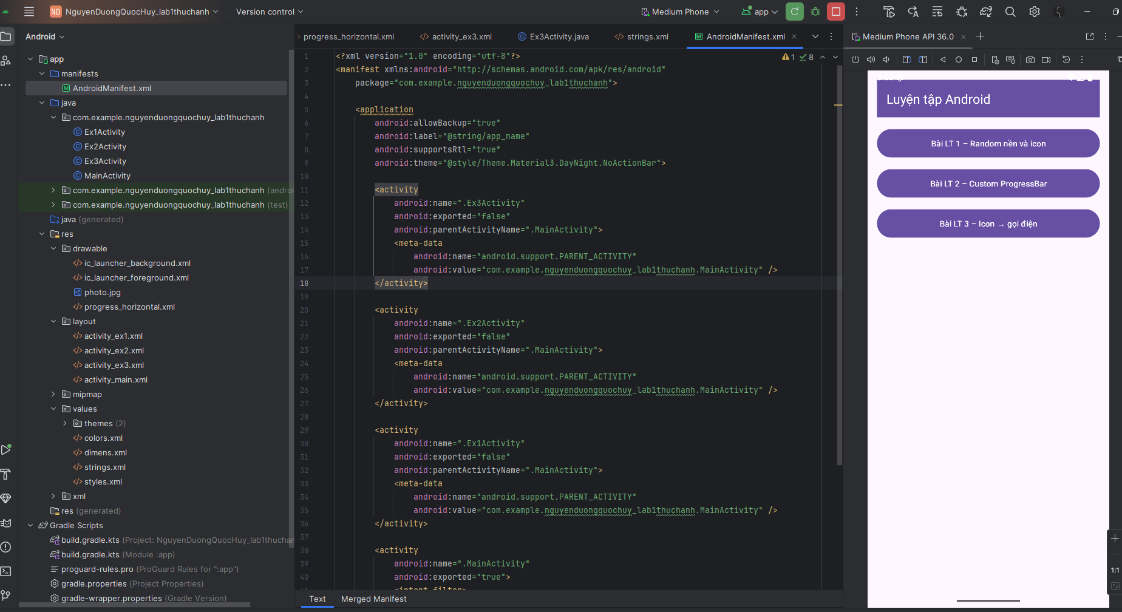

**Bài tập 5:** Thiết kế giao diện theo link hướng dẫn sau:

(<https://www.youtube.com/watch?v=Ca7Te545ELU>)

**1.app/src/main/res/layout/activity_main.xml**

<?xml version="1.0" encoding="utf-8"?>  
<androidx.constraintlayout.widget.ConstraintLayout  
 xmlns:android="http://schemas.android.com/apk/res/android"  
 xmlns:app="http://schemas.android.com/apk/res-auto"  
 android:layout_width="match_parent"  
 android:layout_height="match_parent">  
  
 <FrameLayout  
 android:id="@+id/header"  
 android:layout_width="0dp"  
 android:layout_height="260dp"  
 android:background="@color/indigo_700"  
 app:layout_constraintTop_toTopOf="parent"  
 app:layout_constraintStart_toStartOf="parent"  
 app:layout_constraintEnd_toEndOf="parent">  
  
 <TextView  
 android:id="@+id/tvTitle"  
 android:layout_width="wrap_content"  
 android:layout_height="wrap_content"  
 android:text="@string/discover"  
 android:textColor="@android:color/white"  
 android:textStyle="bold"  
 android:textSize="22sp"  
 android:layout_marginStart="20dp"  
 android:layout_marginTop="20dp" />  
  
 <ImageView  
 android:id="@+id/imgHero"  
 android:layout_width="220dp"  
 android:layout_height="160dp"  
 android:layout_gravity="center_horizontal|bottom"  
 android:layout_marginBottom="16dp"  
 android:scaleType="centerInside"  
 android:contentDescription="@string/hero_desc"  
 android:src="@android:drawable/ic_menu_gallery"/>  
 </FrameLayout>  
  
 <com.google.android.material.card.MaterialCardView  
 android:id="@+id/cardsHost"  
 android:layout_width="0dp"  
 android:layout_height="wrap_content"  
 android:layout_marginStart="16dp"  
 android:layout_marginEnd="16dp"  
 android:translationY="-40dp"  
 app:cardBackgroundColor="@android:color/white"  
 app:cardCornerRadius="20dp"  
 app:cardElevation="8dp"  
 app:layout_constraintTop_toBottomOf="@id/header"  
 app:layout_constraintStart_toStartOf="parent"  
 app:layout_constraintEnd_toEndOf="parent">  
  
 <GridLayout  
 android:layout_width="match_parent"  
 android:layout_height="wrap_content"  
 android:rowCount="2"  
 android:columnCount="3"  
 android:padding="12dp">  
  
 <com.google.android.material.card.MaterialCardView  
 style="@style/DashboardTile"  
 android:layout_columnWeight="1"  
 app:cardBackgroundColor="@color/green_tile">  
 <LinearLayout style="@style/TileContent">  
 <ImageView style="@style/TileIcon"  
 android:src="@android:drawable/checkbox_on_background"/>  
 <TextView style="@style/TileText" android:text="@string/new_arrival"/>  
 </LinearLayout>  
 </com.google.android.material.card.MaterialCardView>  
  
 <com.google.android.material.card.MaterialCardView  
 style="@style/DashboardTile"  
 android:layout_columnWeight="1"  
 app:cardBackgroundColor="@color/pink_tile">  
 <LinearLayout style="@style/TileContent">  
 <ImageView style="@style/TileIcon"  
 android:src="@android:drawable/ic_menu_share"/>  
 <TextView style="@style/TileText" android:text="@string/link_saved"/>  
 </LinearLayout>  
 </com.google.android.material.card.MaterialCardView>  
  
 <com.google.android.material.card.MaterialCardView  
 style="@style/DashboardTile"  
 android:layout_columnWeight="1"  
 app:cardBackgroundColor="@color/yellow_tile">  
 <LinearLayout style="@style/TileContent">  
 <ImageView style="@style/TileIcon"  
 android:src="@android:drawable/ic_menu_mylocation"/>  
 <TextView style="@style/TileText" android:text="@string/my_home"/>  
 </LinearLayout>  
 </com.google.android.material.card.MaterialCardView>  
  
 <com.google.android.material.card.MaterialCardView  
 style="@style/DashboardTile"  
 android:layout_columnWeight="1"  
 app:cardBackgroundColor="@color/purple_tile">  
 <LinearLayout style="@style/TileContent">  
 <ImageView style="@style/TileIcon"  
 android:src="@android:drawable/ic_menu_view"/>  
 <TextView style="@style/TileText" android:text="@string/eye_stream"/>  
 </LinearLayout>  
 </com.google.android.material.card.MaterialCardView>  
  
 <com.google.android.material.card.MaterialCardView  
 style="@style/DashboardTile"  
 android:layout_columnWeight="1"  
 app:cardBackgroundColor="@color/teal_tile">  
 <LinearLayout style="@style/TileContent">  
 <ImageView style="@style/TileIcon"  
 android:src="@android:drawable/ic_input_add"/>  
 <TextView style="@style/TileText" android:text="@string/pro_account"/>  
 </LinearLayout>  
 </com.google.android.material.card.MaterialCardView>  
  
 <com.google.android.material.card.MaterialCardView  
 style="@style/DashboardTile"  
 android:layout_columnWeight="1"  
 app:cardBackgroundColor="@color/blue_tile">  
 <LinearLayout style="@style/TileContent">  
 <ImageView style="@style/TileIcon"  
 android:src="@android:drawable/ic_menu_agenda"/>  
 <TextView style="@style/TileText" android:text="@string/recent_files"/>  
 </LinearLayout>  
 </com.google.android.material.card.MaterialCardView>  
  
 </GridLayout>  
 </com.google.android.material.card.MaterialCardView>  
  
</androidx.constraintlayout.widget.ConstraintLayout>

**2.app/src/main/res/values/styles.xml**

<resources>  
 <style name="DashboardTile" parent="Widget.Material3.CardView.Elevated">  
 <item name="android:layout_width">0dp</item>  
 <item name="android:layout_height">110dp</item>  
 <item name="android:layout_margin">8dp</item>  
 <item name="cardCornerRadius">16dp</item>  
 <item name="cardElevation">3dp</item>  
 </style>  
  
 <style name="TileContent">  
 <item name="android:layout_width">match_parent</item>  
 <item name="android:layout_height">match_parent</item>  
 <item name="android:orientation">vertical</item>  
 <item name="android:gravity">center</item>  
 <item name="android:padding">12dp</item>  
 </style>  
  
 <style name="TileIcon">  
 <item name="android:layout_width">36dp</item>  
 <item name="android:layout_height">36dp</item>  
 <item name="android:tint">@android:color/white</item>  
 </style>  
  
 <style name="TileText">  
 <item name="android:layout_width">wrap_content</item>  
 <item name="android:layout_height">wrap_content</item>  
 <item name="android:textColor">@android:color/white</item>  
 <item name="android:textStyle">bold</item>  
 <item name="android:gravity">center</item>  
 <item name="android:paddingTop">8dp</item>  
 </style>  
</resources>

**3.app/src/main/res/values/colors.xml**

<resources>  
 <color name="indigo_700">#4932C6</color>  
 <color name="green_tile">#19C094</color>  
 <color name="pink_tile">#FF5C8D</color>  
 <color name="yellow_tile">#F7B733</color>  
 <color name="purple_tile">#6B4EFF</color>  
 <color name="teal_tile">#1DB9C3</color>  
 <color name="blue_tile">#6EC6FF</color>  
</resources>

**4.app/src/main/res/values/strings.xml**

<resources>  
 <string name="app_name">Discover</string>  
 <string name="discover">Discover</string>  
 <string name="hero_desc">Minh hoạ</string>  
 <string name="new_arrival">New&#10;Arrival</string>  
 <string name="link_saved">Link&#10;Saved</string>  
 <string name="my_home">My&#10;Home</string>  
 <string name="eye_stream">Eye&#10;Stream</string>  
 <string name="pro_account">Pro&#10;Account</string>  
 <string name="recent_files">Recent&#10;Files</string>  
</resources>

**5.app/src/main/java/com/example/nguyenduongquochuy_lab1thuchanh/MainActivity.java**

package com.example.nguyenduongquochuy_lab1thuchanh;

import android.os.Bundle;

import androidx.appcompat.app.AppCompatActivity;

public class MainActivity extends AppCompatActivity {

@Override protected void onCreate(Bundle savedInstanceState) {

super.onCreate(savedInstanceState);

setContentView(R.layout.activity_main);

}

}

**6.app/src/main/AndroidManifest.xml**

<?xml version="1.0" encoding="utf-8"?>  
<manifest xmlns:android="http://schemas.android.com/apk/res/android"  
 package="com.example.nguyenduongquochuy_lab1thuchanh">  
  
 <application  
 android:allowBackup="true"  
 android:label="@string/app_name"  
 android:supportsRtl="true"  
 android:theme="@style/Theme.Material3.DayNight.NoActionBar">  
  
 <activity  
 android:name=".MainActivity"  
 android:exported="true">  
 <intent-filter>  
 <action android:name="android.intent.action.MAIN"/>  
 <category android:name="android.intent.category.LAUNCHER"/>  
 </intent-filter>  
 </activity>  
  
 </application>  
</manifest>

**Kết quả:**

